MY457 Content Summary for Exam Preparation

Table of Contents:

1. Potential Outcomes Framework
2. Randomised Experiments
3. Selection on Observables
   1. Subclassification
   2. Matching
   3. Weighting
   4. Regression
4. Difference in Differences
5. Instrumental Variables
6. Regression Discontinuity Design
7. **The Potential Outcomes Framework**
8. Potential Outcomes
9. Causal Estimands
10. Identification
11. Assignment Mechanisms

|  |  |  |  |
| --- | --- | --- | --- |
| **Concept** | **Notation** | **Notation = 1** | **Notation = 0** |
| **Treatment** | **Di** | Unit received treatment | Unit did not receive treatment. |
| **Observed Outcome** | **Yi** | Y1i for unit *i* if Di = 1 | Y0i for unit *i* if Di = 0 |
| **Potential Outcome** | **Y1i or Y0i** | Outcome for unit *i* when Di = 1 | Outcome for unit *i* when Di = 0 |

**Assumptions**

1. **SUTVA (Stable Unit Treatment Value Assumption)**
   1. SUTVA is required in order for causal estimates to be made. It validates the following: **Yi = Di * Y1i + (1- Di) * Y0i.** 
      1. Without SUTVA, causal inference is exponentially more difficult as n increases, because we have to estimate all of the potential outcomes and the interactions of potential outcomes across all observations.
   2. For observations in our sample, the potential outcome under a particular combination of treatments for individual *i* is equal to potential outcome under completely different combination of treatments as long as individual *i’s* treatment is the same.
   3. E.g., my potential outcomes have nothing to do with the treatment assignment of anybody else. No matter whether anybody else is taking treatment, if mine is the same then my potential outcomes are stable.
   4. SUTVA consists of two sub-assumptions:
      1. No interference between units
         1. Potential outcomes for a unit are not affected by treatment status of other units.
         2. Violated by spill-over effects, contagion, dilution.
            1. Spill-over: unit *i* gets told by other unit that the treatment has had a specific effect on them, and so unit *i* reports that he perceives the same effect (think paracetamol to fix headaches). If the units around unit i had been allocated to control (no paracetamol) then they wouldn’t have told unit *i* that and the potential outcomes for *i* might be different.
            2. Contagion: If I take a vaccine and no else does, my potential outcomes will look very different to if I take a vaccine and everybody else does (herd immunity).
            3. Dilution: Additional teaching resources get given to class, but only half. Greedy in the treatment group use it all up and thus others have a more ‘diluted’ treatment.
            4. Contagion and Dilution can be characterized as different levels of treatment, seen below.
      2. No different versions of treatment (stability or consistency in treatment).
         1. Nominally identical treatment and in fact identical.
            1. If I give you a pill and say it’s the same, it really needs to be the same.
            2. Violated by variable levels of treatments and technical errors.

The Fundamental Problem of Causal Inference (FPCI)

|  |  |  |  |  |
| --- | --- | --- | --- | --- |
| **i** | **Di** | **Yi** | **Y1i** | **Y0i** |
| **1** | 1 | 3 | 3 | 0 |
| **2** | 1 | 1 | 1 | 1 |
| **3** | 0 | 0 | 1 | 0 |
| **4** | 0 | 1 | 1 | 1 |

*Table 1: I’m all-powerful and can observe fixed values for both Y1i and Y0i. In reality, I only observe one for each observation.*

We can take the values of both Y1i and Y0i to be real and fixed for all *i,* but we can only observe one of them for any i.

|  |  |  |  |  |
| --- | --- | --- | --- | --- |
| **i** | **Di** | **Yi** | **Y1i** | **Y0i** |
| **1** | 1 | 3 | 3 | ? |
| **2** | 1 | 1 | 1 | ? |
| **3** | 0 | 0 | ? | 0 |
| **4** | 0 | 1 | ? | 1 |

*Table 2: I’m a normal researcher, and this is what I really see.*

Formulated as a missing data problem, the missing data is the ***unobserved potential outcomes.*** The goal for the rest of this class is to:

1. Define causal estimands in terms of potential outcomes.
2. Estimate them using observable data.
3. Essentially: fill in the missing counterfactuals as best as possible.

**Estimands, Estimators & Estimates**

**Estimand**

*Definition: The unobserved population parameter or function. The parameter we’re interested in.*

*e.g.,* The popularity of the Conservative party in the United Kingdom.

**Estimator**

*Definition: A function that can be applied to observed data.*

*e.g.,* The sample mean or median of people who like the Conservative party (yes/no opinion poll).

**Estimate**

*Definition: A specific output of said function.*

*e.g.,* A value determining the relative magnitude and direction of the estimator.

**Estimands in Causal Space**

*We will try to estimate these during this course. Estimators of Estimands will be annotated with a hat on top.*

1. ***Individual Treatment Effect***
   1. *Definition: Causal effect of treatment on the outcome for unit i, defined by the comparison of two potential outcomes.*
   2. *Formula: Tau-i = Y1i – Y0i*
   3. This cannot be observed, and is also very hard to estimate:
      1. We cannot observe both potential outcomes Y1i and Y0i for the same unit, i.
      2. Hard to reliably fill in this missing potential outcome for any one unit of i because of potential heterogeneity in treatment effects etc.
         1. How would you find the right counterfactual for unit i specifically and distinguish that counterfactual from the one for observation j specifically.
2. ***Average Treatment Effect (ATE)***
   1. *Definition: The difference in mean outcomes between units assigned to the treatment and units assigned to the control.*
   2. *Formula:* 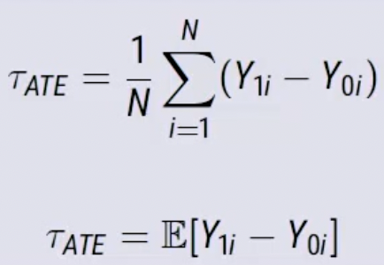
   3. Consider a fixed group (population) of units i=1, ..., N. Values of the potential outcomes for this population can be represented as two vectors:
      1. Y1 = (Y11, Y12, …, Y1N)
      2. Y0 = (Y01, Y02, …, Y0N)
      3. The ATE is the difference in means between both.
   4. Can only be identified under various assumptions.

**Calculation Table:**

*What is Tau-ATE = E[Y1i – Y0i]?*

E[Yi ] = E[Yi | Di = 0] = 0.5

Tau-ATE = E[Yi | Di = 1] - E[Yi | Di]

Tau-ATE = (3+1)/2 – (0+1)/2 = 1.5

|  |  |  |
| --- | --- | --- |
| i | Di | Yi |
| 1 | 1 | 3 |
| 2 | 1 | 1 |
| 3 | 0 | 0 |
| 4 | 0 | 1 |

1. ***Average Treatment Effect on the Treated (ATT)***
   1. *Definition: The average of the individual treatment effects of those treated.*
   2. *Formula:* 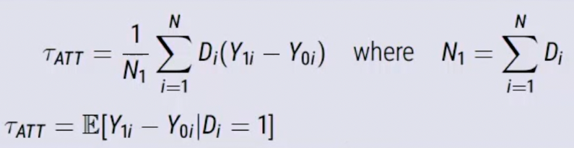
      1. *N1 = number of observations that were treated, in contrast to N which is just number of observations.*
   3. The difference between ATT and ATE is the conditioning on those who received treatment.With ATT, we only pay attention to those where Di = 1.
   4. Tau-ATE = Tau-ATT when control and treatment groups are different in terms of potential outcomes – when there’s some association between treatment status (Di) and potential outcomes (Ydi).
   5. ATT is used when there is some known systematic selection into treatment.

**Calculation Table:**

*E[Y1i | Di = 1] = (3+1)/2 = 2*

*E[Y0i | Di = 1] = (0+1)/2 = 0.5*

*E[Y1i – Y0i | Di = 1] = 2 – 0.5 = 1.5*

*What is Tau-ATT = E[Y1i – Y0i | Di = 1]?*

*Tau-ATT = E[Y1i – Y0i | Di = 1] =* E[Tau-ATT | Di = 1] = (3+0)/2 = 1.5

|  |  |  |  |  |  |
| --- | --- | --- | --- | --- | --- |
| i | Di | Yi | Y1i | Y0I | Tau-i |
| 1 | 1 | 3 | 3 | ? | ? |
| 2 | 1 | 1 | 1 | ? | ? |
| 3 | 0 | 0 | ? | 0 | ? |
| 4 | 0 | 1 | ? | 1 | ? |

1. ***Conditional Average Treatment Effects (CATE) / Local Average Treatment Effect (LATE)***
   1. *Definition: Conditional on Xi, The difference in means between units assigned to the treatment and units assigned to the control.*
   2. *Formula:* 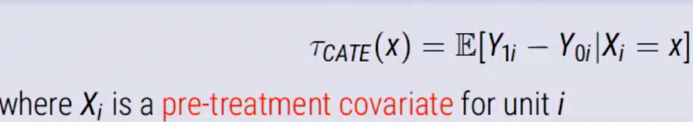
   3. This is a subgroup effect, where treatment effects on units vary by particular characteristics of x (heterogenous treatment effects).
   4. Allows for targeting – I have 5 different dosage regimes. On what covariates are those different dosage regimes most effective?
2. ***Intention to Treat (ITT)***
   1. *Definition: The average of potential outcomes under encouragement minus the potential outcomes under non-encouragement*
   2. *Formula:* 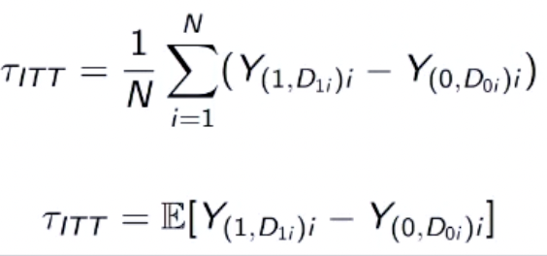
   3. This is the ATE for encouragement. We ignore treatment entirely.
   4. We’re purely interested in difference in potential outcomes in Y under two regimes: encouragement and non-encouragement.
   5. This is the effect of encouragement, regardless of actual treatment assignment.
      1. Because we cannot force all subjects to take the (randomly) assigned treatment/control.
      2. With self-selection into treatment/control groups, Tau-ITT does not equal Tau-ATE.

**Identification**

In statistics, an estimand (parameter) is identified if its value can be uniquely estimated based on the observed data. An identification strategy is a combination of data and assumptions which allows us to identify a causal estimand by estimating (“filling in”) the missing potential outcomes (usually at group level). Selection bias is the difference between your estimator and estimand. We thus need a method or assumption that makes our selection bias equal zero, so that our identification strategy is legitimate (estimator identifies the estimand).

**Selection Bias**

Consider again the naïve difference of observed means in the treatment groups:

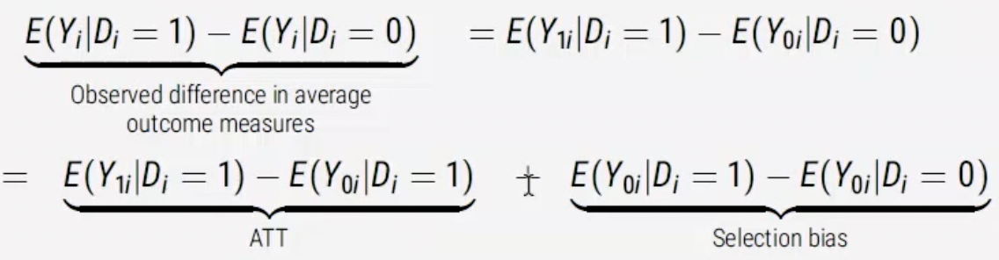

The same observed mean difference could be due to different combinations of the ATT estimand and selection bias terms. Thus, ATT is not identified from the observed mean difference: it is not uniquely mapped from the observed data. We need more assumptions. Correlation [association, here = the observed mean difference] is not necessarily causation.

E(Y0i | Di = 1) – E(Y0i | Di = 0) is selection bias because if it is not 0, it implies treatment and control groups are systematically different in potential outcome Y0i.

THIS MEANS that we cannot, without further assumptions, use the observed control outcome as a good counterfactual for the missing potential outcome, the unobserved potential outcome of control under treatment.

Canonical example: Job training program.

1. Participants are self-selected from a population of individuals in difficult labor situations.
2. Perhaps better resourced or more motivated indivduals decide to take part.
3. In the absence of the program, post-training period earnings for those people would then have been higher than those for who did not opt in.

How do we deal with these identification failures? We add structure to assumptions with the language of ‘assignment mechanisms.’

**Assignment Mechanism**

*Definition: The procedure that determines the treatment status of each unit.*

Most causal inference methods achieve identification by restricting the (assumed) assignment mechanism. For example, if we are willing to assume that treatment assignment is independent of potential outcomes under no treatment then E(Y0i | Di = 1) – E(Y0i | Di = 0) = 0. i.e. selection bias is zero and the observed mean difference is (in expectation) equal to ATT (and also ATE in that case). When would this assumption be plausible? Randomisation!

Imbens & Rubin (2015, Ch. 3) present 3 assumptions about assignment mechanisms that provide the grounds for identification:

1. *Individualistic*: Assignment does not depend on the covariates or potential outcomes for other units.
2. *Probabilistic:* There is a nonzero probability of each treatment value, for every unit.
3. *Unconfoundedness:* Assignment does not depend on potential outcomes.

Thus, we can distinguish two types of design:

1. *Experiments:* The assignment mechanism is both known and controlled by the researcher, and
   1. Within designs, between designs
   2. Unit-randomized, cluster-randomized
2. *Observational Studies:* The assignment mechanism is not known to, or under the control of, the researcher.
   1. “Adjustment-based” solutions:
      1. Regression
      2. Matching
      3. Weighting
   2. “Design-based” solutions:
      1. Difference-in-differences and friends
      2. Instrumental variables
      3. Regression discontinuity designs

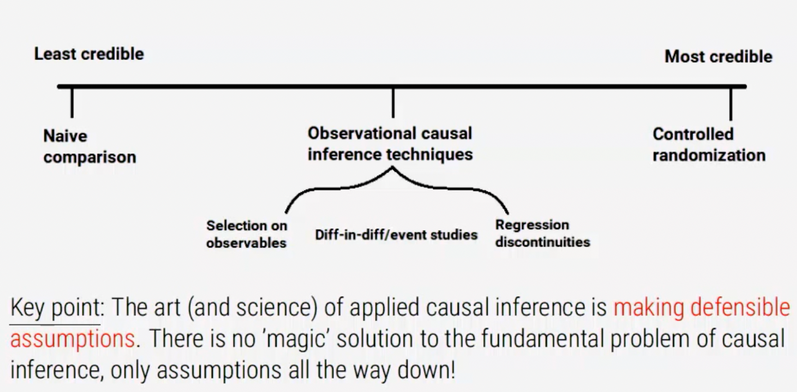

We have leant:

1. To think about causal effects in terms of potential outcomes, not realised (observed) outcomes,
2. Observed association is neither necessary nor sufficient for causality, focusing on one big problem: selection bias,
3. That learning about causal effects should start from understanding the assignment mechanism for treatment and,
4. To evaluate the plausibility of your assumptions to understand the credibility of your conclusions.
5. **Randomised Experiments**

In a (classical) randomized experiment (‘randomized controlled trial’ or RCT) treatment values are assigned to N units at random, with known and positive assignment probabilities for each treatment to each unit. We consider a ‘completely randomized experiment’: a random subset of N1 units assigned to treatment (D=1) and the rest assigned to control.

Randomisation simply provides us with a very defensible assumption.

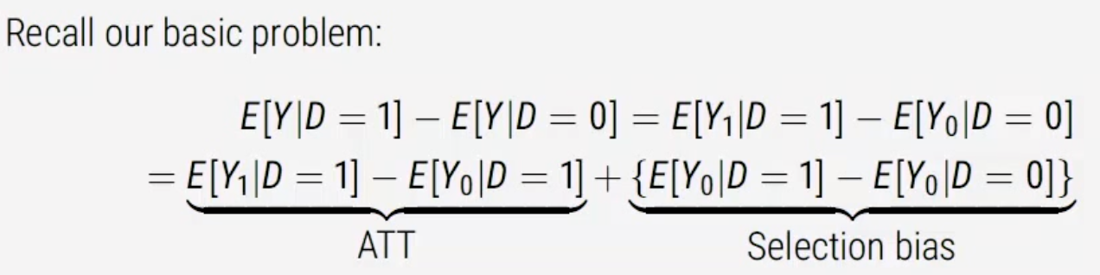

The basic problem is that when we do our naïve difference in means, it turns out that our estimator is not identified because we still have a selection bias term.

Our goal is to find conditions under which our estimator is an unbiased estimator of the estimand of interest. Randomisation implies that assignment probabilities do not depend on potential outcomes (in expectation): P(D | Y0, Y1) = P(D). Think about conditioning as being provided with information regarding the causal statement. Conditionality is only useful if, by conditioning on potential outcomes (or anything, really), we learn more about our subject of study (in the case of P(D | Y0, Y1) = P(D), the assignment mechanism).

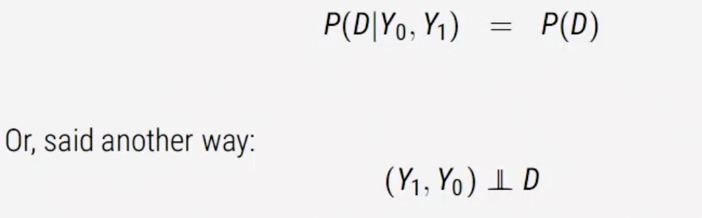

This means that (in expectation) Y0 is the same for those with D = 1 and for those with D = 0 (and similarly for Y1). Randomisation, thus, eliminates selection bias. Under independence from randomized treatment assignment, we have:

E[Y0 | D=1] = E[Y0 | D=0] = E[Y0].

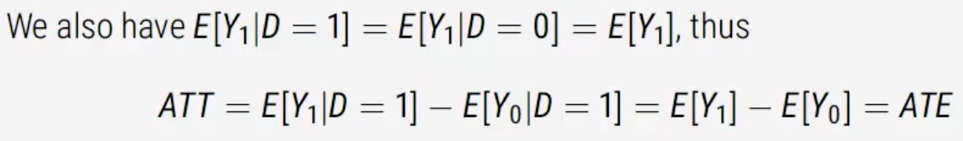

There was no selection into treatment, so ATT = ATE, right? THUS, the observed difference in means (estimator) between the treatment group identifies the causal average treatment effect ATE (as well as ATT and ATU, which both equal to ATE in this case). We can also identify most other population-level causal effects, since they are comparisons of some features of the distributions of Y0 and Y1 and we can now estimate both of these distributions.

**A Sampling Analogy for Randomisation**

1. Under randomization, the N0 (number of obs for whom potential outcome Y0i is realised, so those in control) values of Y0i that we observed (for those assigned to Di = 0) are a simple random sample of the N values of Y0i in the population (and similarly for Y1i).
2. We can thus estimate the population distributions of Y0i and Y1i (and any statistics of them) from these ‘samples.’
3. Since population-level causal effects are comparisons of statistics of these distributions, we can also estimate (identify) those causal effects.

**Covariate Balance**

In expectation, randomization balances all observed and unobserved pre-treatment characteristics between treatment and control groups. In any one experimental sample, we might expect some chance imbalance. We can check random assignment with respect to *observed* covariates *X* using so-called “balance tests” (e.g. t-tests or equivalence tests) to see if the distributions p(X | D = 1) and p(X | D = 0) are not meaningfully different. Exact balance in some X can be ensured with stratified randomization.

**Complications and Limitations of Randomisation and Experiments**

1. Randomisation (and thus internal validity) can be complicated by:
   1. Missing data (dropout/attrition)
      1. Outcome is unobserved for some units in a way that is associated with D or potential outcomes.
   2. Non-compliance:
      1. some units receive a different treatment than the one they were assigned to.
2. Randomisation does not help with external validity.
   1. How well do causal effects for this sample apply to broader population, or other populations?
      1. Can differentiate sample ATE (SATE) from population ATE (PATE) – randomization identifies SATE, but PATE also requires random sampling. Moving to a different population entirely would require other assumptions.
3. Randomised experiments can be weak in construct validity (Shadish, Cook & Campbell)
   1. How well do the versions of treatment and outcome in the experiment match the concept we are actually substantively interested in?

**Estimation and Inference**

Our estimator is only unbiased if we can assume that potential outcomes are independent of treatment. Randomisation solves this.

Now, how do we actually estimate that number?

1. Estimation
   1. We can use the observed probability distributions p(Y | D = 1) and p(Y | D = 0) in the observed data to estimate the distributions of Y1 and Y0 in the population, and thus population causal effects.
2. Statistical Inference
   1. Hypothesis tests and confidence intervals tend to be based on the “source of identifiying variation.”
   2. See ch. 5-9 Imbens & Rubin.
   3. We are trying to learn something about the unlikeliness of the observed data and results occurring.

**Estimating ATE**

Tau-ATE = E[Y1] – E[Y0] (both unobserved, as they’re not conditional on D). This is thus an estimand, as we cannot observe it directly and need to find a way to estimate it. An obvious estimator of this is the sample difference-in-means: Tau-hat = Y1-hat – Y0-hat.

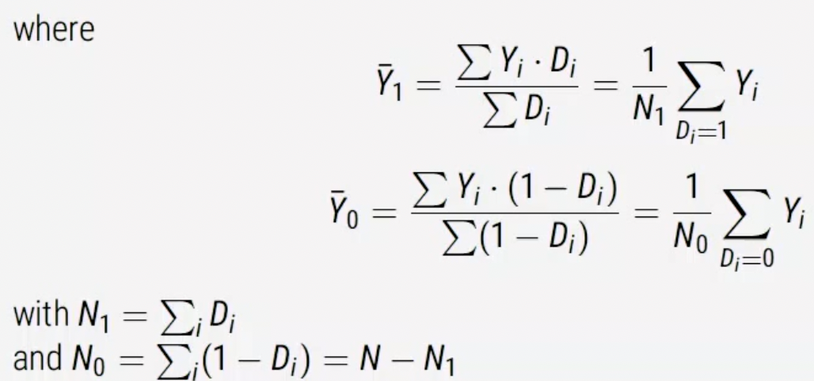

We have already proven that Tau-hat is an unbiased estimator of Tau-ATE under randomization, as we eliminate selection bias through randomization. ***DO THIS PROOF.***

The same Tau-ATE can be estimated using a linear regression model:

Yi = alpha-hat + Tau-hat (replaces beta coefficient) * Di + epsilon-i-hat

Recall Tau-hat from a bivariate regression with a binary independent variable is mathematically equivalent to the difference-in-means. It is not necessary to include covariates X in this model to get an unbiased estimator of Tau because randomization de-correlates covariates with treatment. However, pre-treatment covariates are sometimes included because they raise the precision of our estimator (thus dropping out P-values) as they are modelling residual variation in Y. ESPECIALLY if you’re controlling for a pre-treatment level of Y. Thus, you can control for observable imbalance. We can allow for estimation of heterogenous treatment effects by *X* (by including interactions in this model). BUT – there is a small risk of inducing bias (bias-variance tradeoff).

**Two Sample T-Test for Inference**

Under Null hypothesis, Tau-ATE = 0. 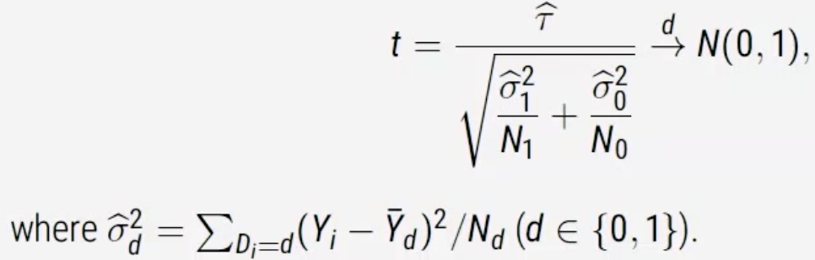

For the treated (D = 1), the difference between the mean for the treated and the observed is unlikely to be as large as it is. For those in control (D = 0), the difference between the mean for the treated and the observed is unlikely to be as large as it is. Intuitively, this is just measuring dispersion in the data.

**Think about it:**

1. Could have 2 distributions with same mean but one has a much wider distribution that the other.
2. The bigger your point estimate and more precise your data is, the bigger T-statistic is going to be.
3. T is small when data is super dispersed because your denominator gets big, or gets really small when the tau is small.

We reject the null hypothesis that Tau-ATE = 0 against the alternative Tau-ATE does not equal 0 at the asymptotic 5% significance level if t > 1.96 or t < -1.96.

For the two-sample t-test, the null hypothesis was that the average treatment effect Tau-ATE is zero. Consider instead, the sharp null hypothesis (and alternative) i.e. that all individual causal effects are zero.

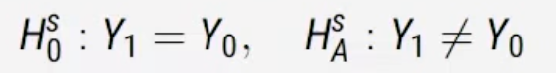

If we assume the sharp null hypothesis to be true, then Y1 = Y0, so we get both if we have one. We can do this because under the sharp null the observed data Yi for every unit would have been exactly the same, no matter the value of Di.

**Randomisation Inference**

1. Logic of randomization inference (permutation test, Fisher’s exact test);
   1. **Permute** the values of Di (N1 1s and N0 0s) differently across the N units, keeping Yi unchanged.
   2. **Calculate and store** the values of Tau-hat-j (or any other appropriate statistic, such as the t-test stat) for each of these permuted datasets j.
   3. **Calculate p-value** as the proportion of Tau-hat-j that are as or more extreme than the actually observed Tau-hat.
      1. With small N, we can consider all the permutations of Di
         1. Ther are (N N1) = N! / (N1! N0!) of them.
      2. With large, take a random sample.

**Example of Randomisation Inference**



32/4 – 8/2 = 6 (Tau-hat)

**NOW, we can permute all (8 4) = 70 possible assignments**

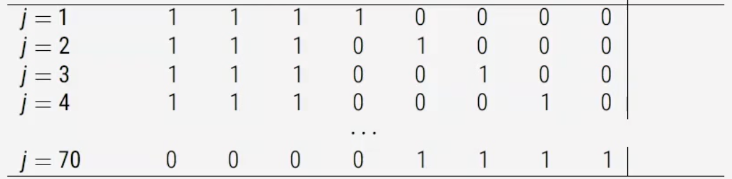

We can then calculate the sample mean differences that would have been obtained for each of them if the sharp null hypothesis were true.

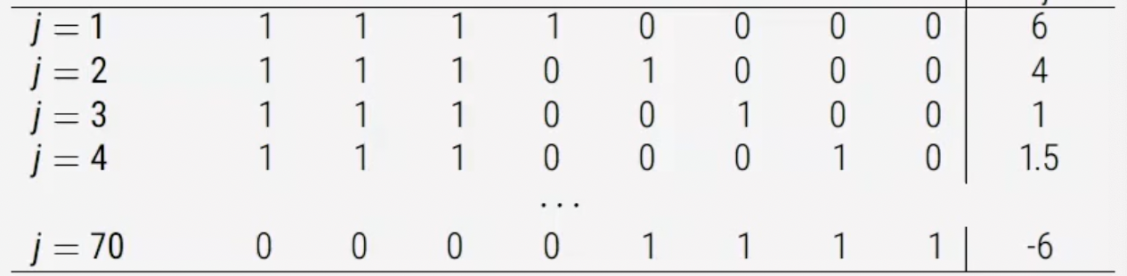

We can build a distribution and put our real, observed difference in means on said distribution, like so:

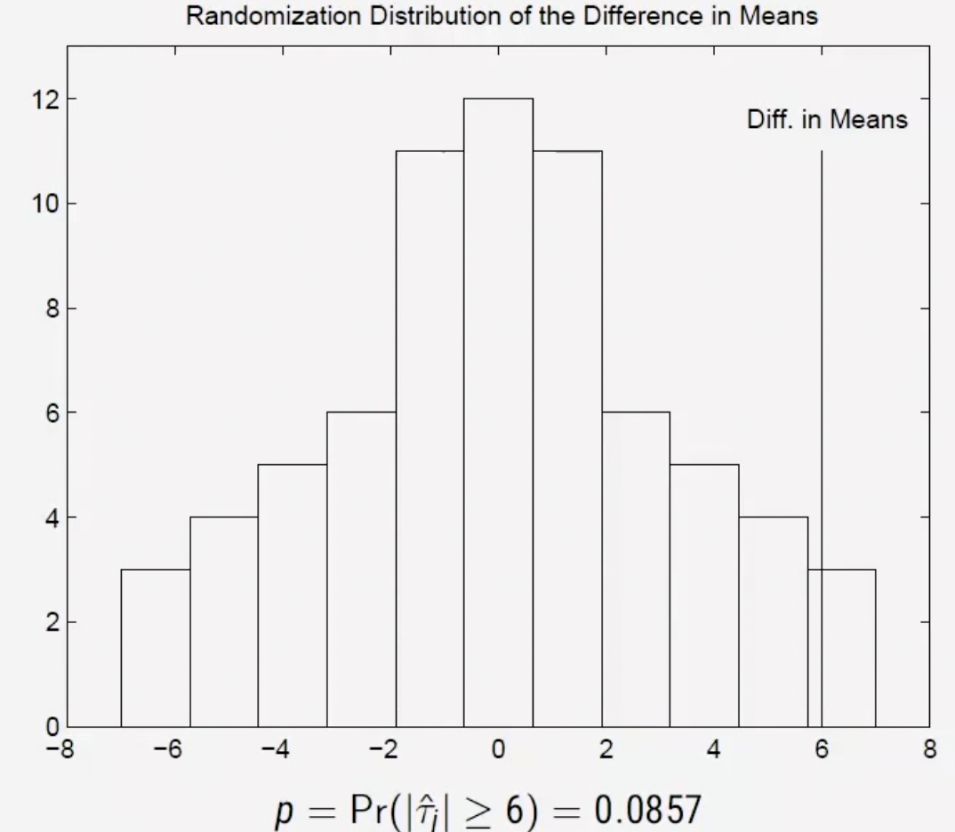

The above uses an empirical distribution under the sharp null hypothesis rather than gaussian properties based on sampling and statistical theory.

**Bootstrap**

Basic idea: Simulate the sampling distribution of a statistic via resampling with replacement. This is built on the idea that there is no better place to learn about the sampling distribution than the sample we actually drew from population (assuming it’s a good sample).

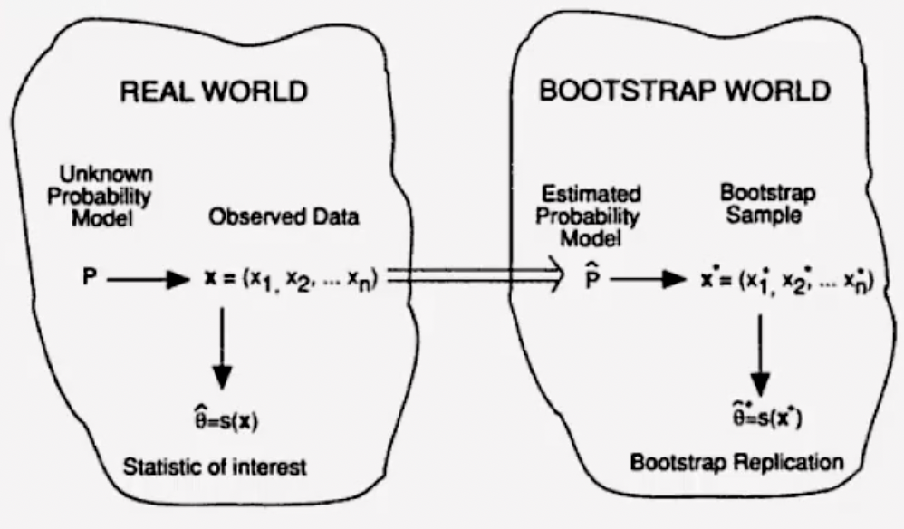

*This is not a solution for small samples!*

Goals:

1. Estimate uncertainty in Theta-hat (any statistic or parameter of interest)

Useful when:

1. Statistic is so complicated that analytically deriving its sampling variance is too difficult or cumbersome.
2. Data are so skewed that inference based on asymptotic normality is unlikely to perform well.
3. Statistic is of a form that makes CLT kick in only slowly, so normal approximation does not work well.
4. If *n* is sufficiently large, the sample *X* should be a good approximation of P.

Nonparametric Bootstrap Process:

1. Draw *B* resamples of size *n* (size of sample) from *X* (sample) **with replacement.**
2. For each X*b, compute parameter of interest (Theta-hat).
3. Use sample standard deviation from bootstraps to define bootstrap standard errors.
4. Compute 95% CI, otherwise known as the bootstrap percentile CI.
5. If we can assume that theta-hat is approximately normally distributed, we can use the bootstrap normal CI.

Parametric Bootstrap Process:

1. If you can assume that P = P(Theta), you can resample from P(Theta-hat), a parametric estimate of P.
2. This is more efficient at the cost of assuming a model.

Block Bootstrap Process:

1. When observations are clustered, resample clusters with replacement instead of individual units.
2. **Selection on Observables**

**Goal: To design observational studies such that we believe causal effects are still identified and understand the assumptions underpinning these designs.**

**Pre-Treatment Covariates**

*Definition:* Any variable *X* that is predetermined with respect to the treatment *D,* such that the value of *Xi* for each unit *i* does not depend on the value of *Di.*

*Laymans definition:* Any variables (observed or unobserved) that are not affected by the treatment assignment and is unrelated to treatment assignment.

1. This implies that there are no potential outcomes X0i and X1i with respect to this treatment, D, just one value Xi which is taken as fixed for the purpose of our analysis.
2. X and D may still be associated if the treatment assignment for D is causally affected by X.
   1. There might be selection into treatment!
3. X may include characteristics that are immutable (e.g. age) or they may be causally affected by other things (e.g. income).
4. X may include baseline (pre-treatment) measures of Y.

In the graph next to us, we want to control for X (pre-treatment), but not for V (post-treatment).

We want to control for X because the effect of D on Y might be dependent on X.

We don’t want to control for V as doing so might absorb some of the impact of D on Y, as it could be a post-treatment mechanism that affects Y.

Quite often, this can be a bit trickier than it seems…

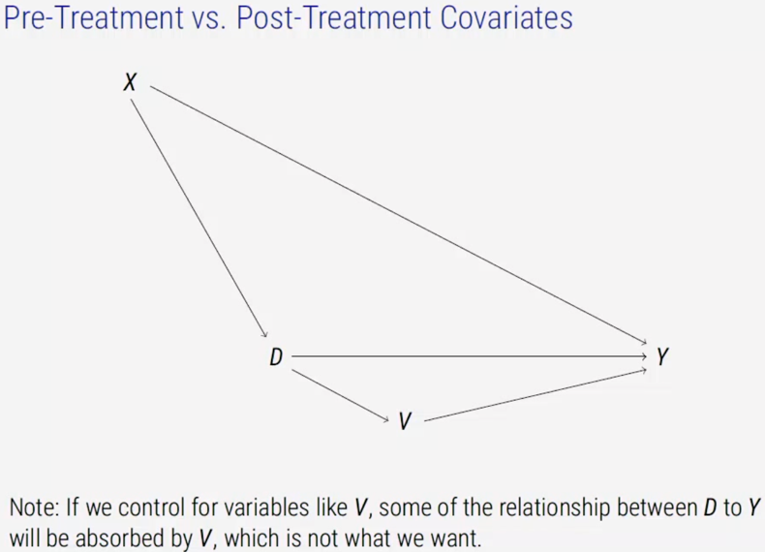

We can see how much of the effect of D on Y is ‘through’ V by controlling for V and comparing to non-controlled regression. This is pretty old-school, though!

**Identification Assumptions**

1. In randomized experiments, Di satisfies
   1. (Yi0, Yi1) is independent of Di.
2. We now instead make the **conditional ignorability/independence (CI) assumption:**
   1. (Yi0, Yi1) is independent of Di CONDIITONAL ON Xi = x for any x in the space of X.
   2. This is also called exogeneity, selection on observables, no omitted variables.
   3. Read like: among units with identical values of Xi, Di, is ‘as-if’ random.
   4. So, once you’re studying those where level of education = ‘PhD,’ (Yi0, Yi1) is independent of Di.
   5. If there’s no confounding variable, we can drop the conditioning.
   6. SO: ONCE WE CONDITION ON X, WE GET CONDITIONAL INDEPENDENCE BETWEEN POTENTIAL OUTCOMES AND TREATMENT.
      1. Essentially, we are assuming that once we condition on X, then the assignment of D is ‘as good as random.’
3. We also need the common support (positivity) assumption:
   1. The probability of receiving treatment for any given level of X is never 0 and never 1.
   2. With any value of Xi, *i* could have received treatment or control.

**Identification Results (in exchange for those assumptions)**

**ATE**

1. In randomized experiments, we considered identification with population difference in means:
   1. Tau-hat = Expected value of Yi where treatment = treatment, minus the expected value of Yi where treatment = control.
   2. Tau-hat = E[Yi | Di = 1] - E[Yi | Di = 0]
2. Here, we use difference in the population regression functions:
   1. Tau-hat(x) = Expected value of Yi where treatment = treatment and Xi = x, minus the expected value of Yi where treatment = control and Xi = x
   2. Tau-hat = E[Yi | Di = 1, Xi = x] - E[Yi | Di = 0, Xi = x]
3. We need to **weight** our estimations of Yi based on the proportion of Xi = x in treatment and control.
   1. Result: under the conditional ignorability and common support assumptions, Tau is nonparametrically identified as:
      1. Tau-ATE = E[Tau-hat(Xi)]
      2. Tau is nonparametrically identified as the expectation of Tau-hat over all values of X.
      3. So, Tau-ATE is basically a weighted average of Tau-hat(Xi)’s.
      4. The **weight** in this context is the proportion of Xi = x in the data.

**ATT**

1. Tau-ATT is also nonparametrically identified under the conditional ignorability and common support assumptions as:
   1. Tau-ATT = E[Tau-hat(Xi) | Di = 1]
   2. The ATT lets us *weaken our assumptions,* 
      1. we only know need conditional ignorability for our missing control potential outcome, not our missing treatment potential outcome.
      2. There can now also be observations where probability of control = 1, and therefore could never be treated
2. Tau-ATE and Tau-ATT are not necessarily equal when conditional ignorability holds as Di is not necessarily unconditionally random (it is conditionally random).

We now consider four broad estimation approaches which rely on the conditional independence assumptions:

1. Subclassification
2. Matching
3. Weighting
4. Regression

**Subclassification**

**If Xi is all discrete, the identification results can be rewritten as:**

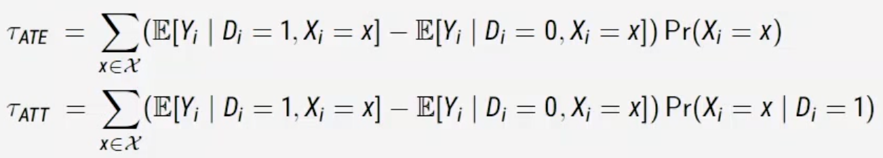

What are the weights? The weights are the probability that Xi = x.

**Tau-ATE can be calculated by:**

1. Group units into strata defined by values of Xi.
2. For each statum, calculate the difference in means of Yi.
3. Take weighted average of (2), where weights are the proportion of units per strata.

**Tau-ATT can be calculated by:**

1. Group units into strata defined by values of Xi.
2. For each statum, calculate the difference in means of Yi.
3. Take weighted average of (2), where weights are the proportion of units per strata within the treatment group.

So, if we have 2 binary Xs, we have 4 strata.

For each strata, from strata 1 to strata 4, we are going to take the difference in means in Y between the treated and control for that stratum. We then multiply this value by the proportion that the stratum represents in the total sample.

We do the same for ATT, except we now multiple value by proportion that the stratum represents in treated.

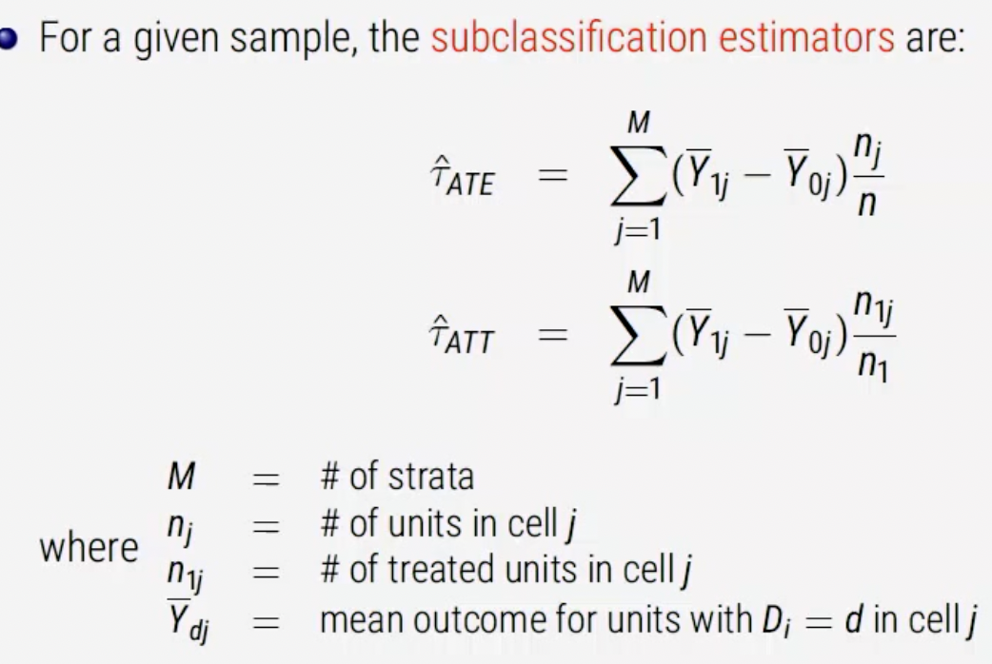

A canonical example for this is the Smoking and Mortality (Cochran 1968) paper, that tries to measure the effect of smoking on mortality.

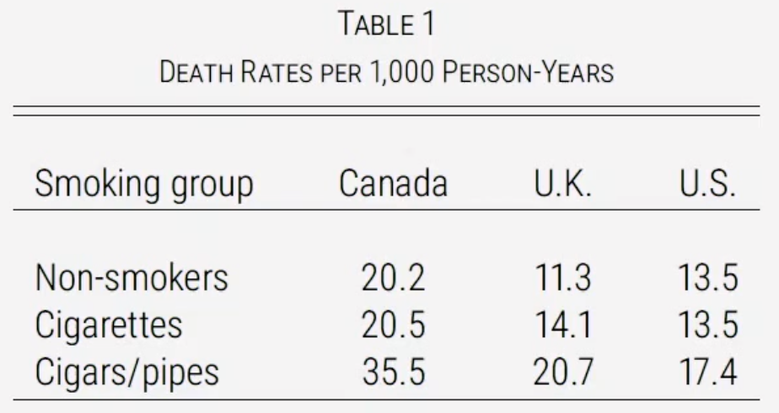

The issue with the above is that different types of people select into smoking different things, and those variables that define ‘different types of people’ might also affect relative mortality. For example, old people smoke cigars & cigarette smokers are younger than non-smokers.

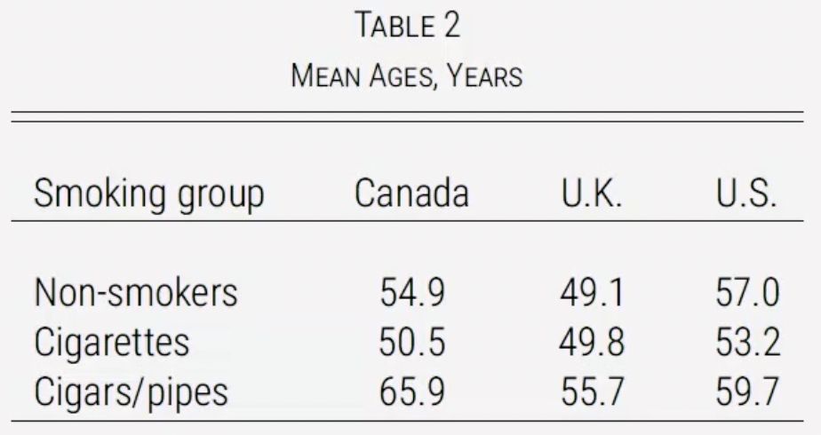

To control for differences in age, we would like to compare different smoking-habit groups with the same age distribution.

So we’re going to do the following:

1. For each county, divide each group into different age subgroups,
2. Calculate death rates within each age subgroup,
3. Average within subgroup death rates using fixed weights (e.g. the number of ciggie smokers),

|  |  |  |  |
| --- | --- | --- | --- |
| Age | Death Rate – Pipe Smokers | # Pipe Smokers | # Non-smokers |
| 20-50 | 0.15 | 11 | 29 |
| 50-70 | 0.35 | 13 | 9 |
| 70+ | 0.5 | 16 | 2 |
| Total |  | 40 | 40 |

We have common support because we have data in every cell.

What is the average death rate for pipe smokers?

- 0.15 * (11/40) + 0.35 * (13/40) + 0.5*(0.4/40) = 0.04125 + 0.11375 + 0.2 = 0.355

What is the average death rate for pipe smokers if they had the same age distribution as non-smokers?

- 0.15 * (29/40) + 0.35 * (9/40) + 0.50 * (2/40) = 0.10875 + 0.07875 + 0.025 = 0.2125

**So, we adjust the death rates based on the underlying population distribution of age variable.**

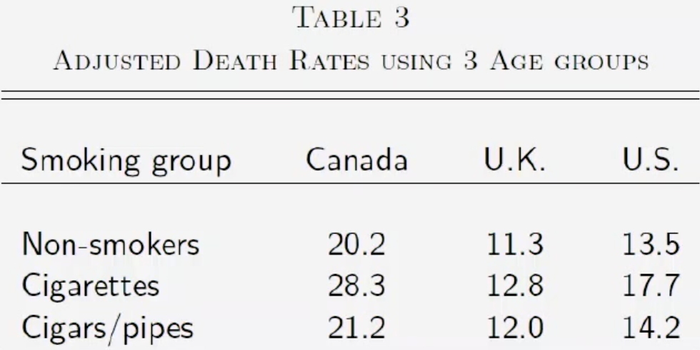

*Now, if we have two categories ‘old’ and ‘young.’ (M = 2)*

What is the **subclassification estimator for the ATE** of smoking on death rate?

|  |  |  |  |  |
| --- | --- | --- | --- | --- |
| Xj | DR smokers | DR Non-smokers | Smokers | # Obs |
| Old | 0.28 | 0.24 | 3 | 10 |
| Young | 0.22 | 0.16 | 7 | 10 |
| Total |  |  | 10 | 20 |

**Tau-hat-ATE = (0.28 – 0.24) * 10/20 + (0.22 – 0.16) * 10/20 = 0.02 + 0.03 = 0.05**

What is the **subclassification estimator for the ATT** of smoking on death rate?

**Tau-hat-ATT = (0.28 – 0.24) * 3/10 + (0.22 – 0.16) * 7/10 = 0.012 + 0.042 = 0.054**

*Now, if we have four categories ‘old,’ ‘young,’ ‘male,’ and ‘female’’ (M = 4)*

|  |  |  |  |  |
| --- | --- | --- | --- | --- |
| Xj | DR smokers | DR Non-smokers | # Smokers | # Obs |
| Old, Male | 0.28 | 0.22 | 3 | 7 |
| Old, Female |  | 0.24 | 0 | 3 |
| Young, Male | 0.21 | 0.16 | 3 | 4 |
| Young, Female | 0.23 | 0.17 | 4 | 6 |
| Total |  |  | 10 | 20 |

What is the **subclassification estimator for the ATE** of smoking on death rate?

*It can’t be identified as we don’t have common support! So, we focus on the ATT.*

What is the **subclassification estimator for the ATT** of smoking on death rate?

Tau-ATT = (0.28 – 0.22) * 3/10 + (0.21 – 0.16) * 3/10 + (0.23 – 0.17) & 4/10 = 0.06*0.3 + 0.05*0.3 + 0.06*0.4 = 0.057

**Matching**

Subclassification only works when all covariates in Xi are discrete. An alternative when some/all of Xi are continuous: matching. The basic idea is to impute missing potential outcomes using observed outcomes of ‘closest’ units (a.k.a. nearest neigbours).

Basic process:

1. For each observation in the treated group i, find an observation in the untreated group with the most similar values of *X.*
2. Estimate ATT by the average difference between the pairs.
   1. *Can only do the ATT as we’re only finding a ‘buddy’ for those that are treated.*
3. 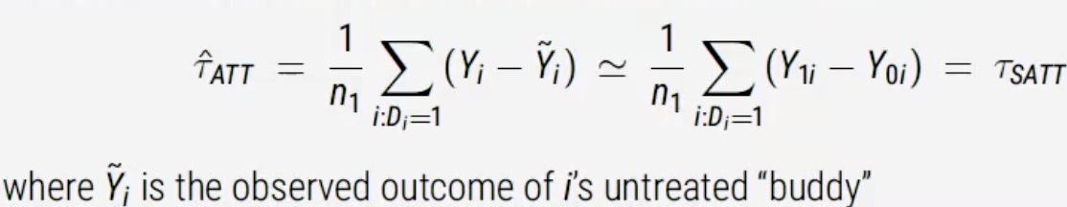
4. We could have multiple close units and use the average of them.

Even more basic:

1. Find the matching ‘buddy’ for i in treatment.
2. Calculate difference.
3. Done.

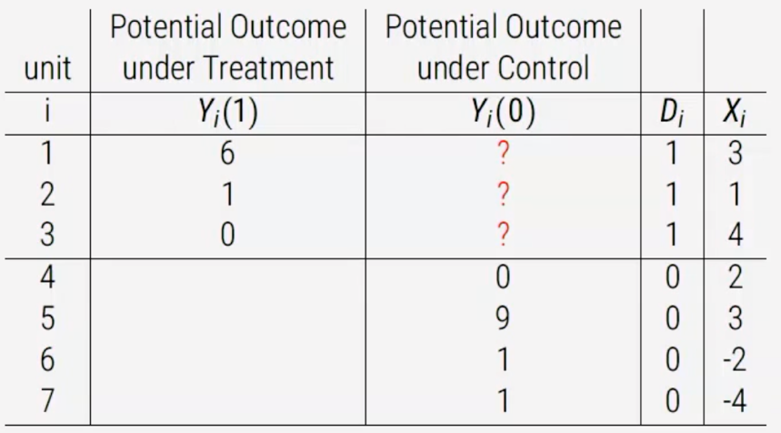

We see realised potential outcomes for Yi(1) where Di = 1, and have missing potential outcome for Yi(0) where Di = 1. Let’s find the match with the closest value of Xi in control for each treated unit.

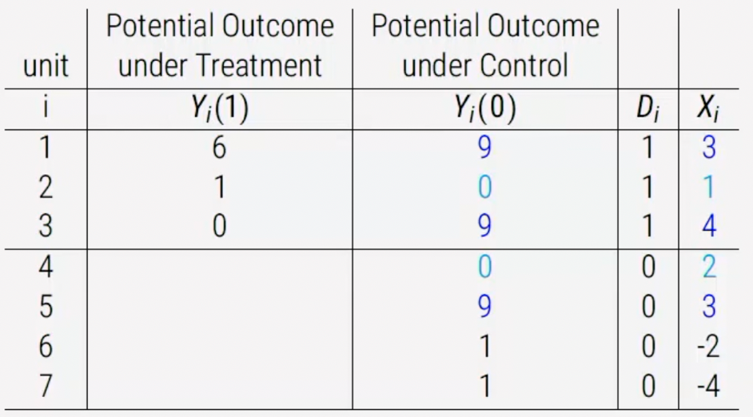

So we’ve matched:

|  |  |  |  |  |
| --- | --- | --- | --- | --- |
| Treated unit | Treated Xi | Control (Matched) unit | Control Xi | Difference in Xi (absolute) |
| 1 | 3 | 5 | 3 | 0 |
| 2 | 1 | 4 | 2 | 1 |
| 3 | 4 | 5 | 3 | 1 |

So, Tau-hat-ATT = 1/3* ( (6 – 9) + (1-0) + (0 – 9) ) = 1/3 * (-3 + 1 – 9) = -3.666.

The ‘match,’ then, is essentially a ‘synthetic clone’ of treated unit (or as close as possible). Matching is an estimation approach within a selection on observables design.

As Xi contains > 1 variable, we run into the curse of dimensionality in that we struggle to find an exact ‘match’ for our unit in control. Data sparsity exponentially increases as we add more variables!

We typically use a multi-variate distance metric where count(variables) < 1, such as:

1. Mahalanobis distance:
   1. 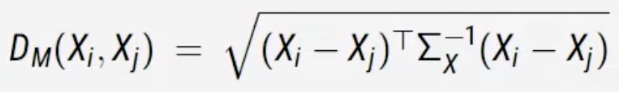
2. Euclidean distance:
   1. 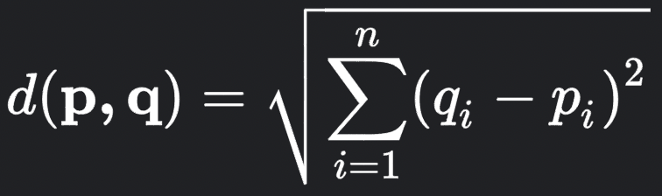
   2. Euclidean distance doesn’t scale, as differing scale lengths means Euclidean distance will prioritise smaller scale.

**Propensity Scoring and the Balancing Property**

*Definition: Probability of receiving treatment given Xi*

*Formula: Pi(Xi) = Pr(Di = 1 | Xi)*

*Laymans: Propensity score is equal to the probability of getting treatment, conditional on values of covariates.*

Suppose conditional ignorability and common support holds:

Then, the propensity score has the balancing property:

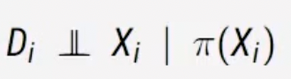

**Di is independent of Xi, conditional on the propensity score**

**Among those units with the same propensity score, Xi is independent of treatment assignment.** The balancing property implies that conditional ignorability holds given just the propensity score, so it is sufficient to just condition on Pi(Xi) (propensity score) instead of Xi.

So, propensity score is squeezing all the Xi per i unit into one single number, the propensity score, and then controls on that.

BUT: there is a catch – we need to estimate Pi(Xi).

How?

1. Estimate Pi(Xi) with a model for a binary response (probability of being in treatment).
2. Do nearest neighbour matching on Pi(Xi).
3. Check balance
   1. Ideally, compare the joint distribution of all Xi between the treated and untreated in the matched sample.
   2. In practice, check various low-dimensional summaries of F(x) such as mean difference, variance ratios etc. to make sure the two groups are very similar!

**Weighting**

We previously said that the best match was based on closest propensity score, which utilizes the balancing property (Matching). An alternative way to achieve balance is weighting. Here, we use a ‘Inverse Propensity Weighted (IPW)’ estimator by weighting each unit by their propensity score.

Formula: 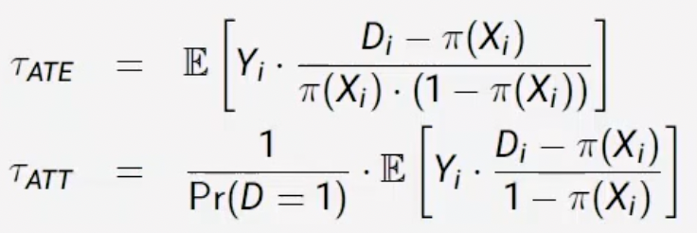

**For treatment, we multiply the Y value of the observed treatment units by 1/propensity_score.**

**For control units, we multiply the Y value of the observed control units by -1/(1-propensity_score)**

**The two above should start to cancel out, with the following results:**

1. If those two quantities are equal, our ATE = 0.
2. If, after adding them together, we have a positive number, the ATE will be positive.
3. If, after adding them together, we have a negative number, the ATE will be negative.

For ATT,

1. Weight for treated units is just 1,
2. Our control units are weighted by --propensity_score/(1--propensity_score).

These inverse probability weighting (IPW) estimators are consistent, but not unbiased. For treated units, when Pi is large then the weights are small. For control when Pi is large, then the weights are also large. This creates a problem – bias becomes substantial when there are lots of extreme values in small samples (called a lack of overlap).

If a unit has a high probability of being in treatment/control and ends up in the opposite category, it gets a very high weight. The intuition is that we can learn a lot from this unit. This unit should have been in control but ended up in treatment – because it looks a lot like the control units.

Through weighting, units do not get dropped like they do with Matching. Instead, some of them get reduced to ‘near zero’ in terms of their contribution to estimating of causal effect.

**Regression (Model-based Estimation of Causal Effects)**

We can also adjust for covariates through a parametric model (regression).

Recall that under conditional ignorability and common support, the ATE/ATT is equal to the weighted averages of the differences in population regression function:

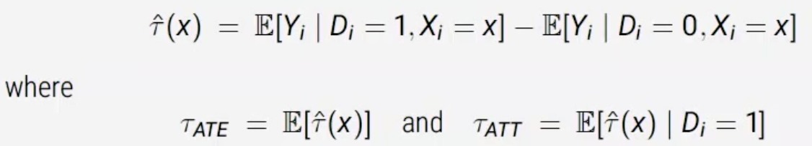

This suggests a model-based approach for estimating causal effects, where we use a regression model for E[Yi | Di, Xi], such as:

**E[Yi | Di, Xi] = Alpha + Beta1*Di + Beta2*Xi**

Which we can estimate with OLS.

**Challenges with Regression**

Once we’ve set all other variables to constant, we can estimate the coefficient on Di. When, cthough, is the coefficient a good estimator of Tau-ATE?

This depends on two big assumptions:

1. Constant Treatment Effect Assumption
   1. We’re assuming that Tau for any individual is equal to Tau for all other individuals.
2. Linearity
   1. We’re assuming that potential outcomes can be written as:
      1. Yi(d) = Alpha + Beta1*d + Beta2*Xi + Epsilon-i (for d = 0,1)

Noting that Linearity implies Constant Treatment Effect Assumption, there are 3 possible scenarios:

1. **Case 1: Constant Treatment Effects & Linear Potential Outcomes**
   1. Both 1 & 2 are true.
   2. Result: if treatment is constant across units and potential outcomes are linear in Xi, then the OLS estimate of Beta1 is an unbiased and consistent estimator of Tau-ATE.
   3. 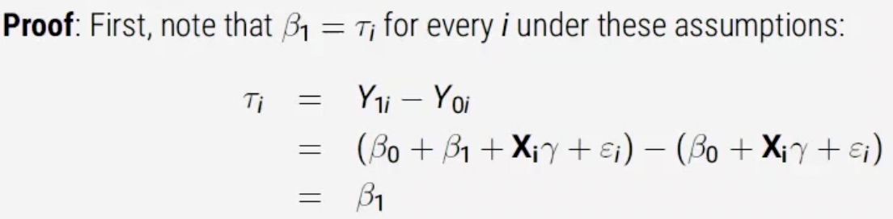
2. **Case 2: Constant Effect w/ Unknown Functional Form (potentially non-linear).** 
   1. 2: Only 1 (Constant effect) is true, but we do not know that functional form is linear.
   2. Beta-OLS still gives us the best *linear* approximation, so it is mis specified.
   3. More flexible models may provide a better performing approximation.
3. **Case 3: Non-constant Treatment Effects**
   1. Treatment effect heterogeneity – For example, effect of social programme is highly conditional on a units age.
   2. Result: the OLS estimator can be written as a subclassification estimator, where the weights come from the conditional variances of Di in each subgroup:
   3. 
      1. The weights are no longer proportion of Xi, it’s the weighted variance.
      2. Var(Di | Xi = X) = Pi(x)*(1 – Pi(x)), therefore:
         1. Weights are high for groups with prop scores close to 0.5
         2. Weights are low for prop scores close to 0 or 1.
      3. I.e. if these Xs are prominent in the data, they will be upweighted (and vice versa), divided by the sum of all the variance in D across all strata of X.
      4. So, we get a big weight when the strata (subgroup) defined by Xi accounts for a large amount of the total variance.
      5. So, OLS is trying to focus its weight on there’s a lot of variability. OLS minimizes estimation uncertainty by downweighing groups where group-specific ATEs are less precisely estimated.
   4. Here, OLS provides an unbiased estimator for a conditional-variance-weighted average treatment effect. This is a causal quantity, but not generally equal to the ATE or ATT.

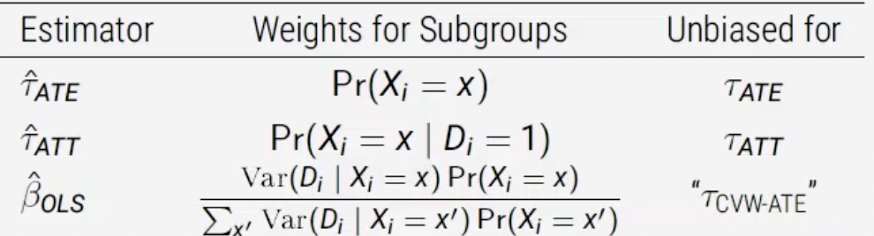

**OLS as a Weighted Average of Estimands (Still Case 3)**

The above weights are applied at the subgroup level. Under some assumptions, and given heterogenous treatment effects, the causal estimand targeted by OLS is:

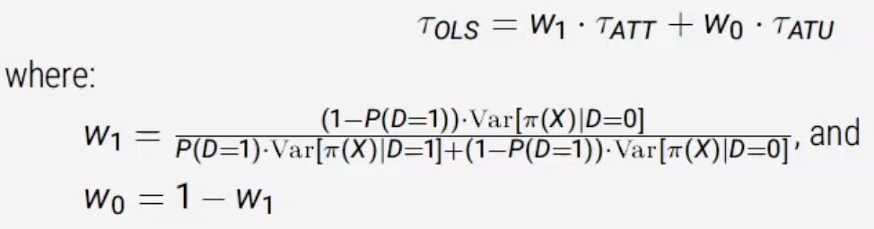

A weighted average of Tau-ATE & Tau-ATU (untreated). (Sloczynski, 2022).

This can admit a strange interpretation:

1. Weights wj are inversely proportion to the share of units in j!
2. This is weird. If you have a lot of treated units, ATU will be upweighted, and ATT downweighted. Why?
   1. For the ATT, OLS is predicting the *missing potential outcomes* for the treated – those come from the coefficients for the control, so these are upweighted. It heavily upweights control units because it is trying to predict the missing counterfactual (if unit under control was treated) and thus pays more attention to control.
3. Solution: weighting, matching, and fully interacting de-meaned X and Di.

**The Fully-Interacted Estimator / Oaxaca-Blinder Estimator (Solution to Case 3)**

One well-regarded large-sample linear regression estimator is as follows:

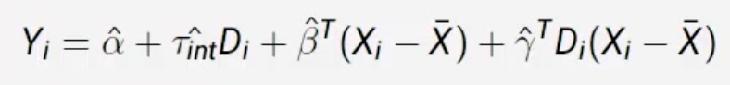

Where:  
Xi are covariates sufficient to satisfy the conditional independence assumption.

X-bar is the sample mean of Xi.

**We’re basically interacting D with every single one of our covariates! We’re doing this because we’re trying to circumvent the constant treatment assumption. If we were just including controlling covariates and not the interaction terms then we’d still be assuming D is constant across all levels of X.**

This estimator has numerous desirable properties:

1. The bias tau-int-hat as an estimator for tau-ATE is arbitrarily small in large samples under only conditional independence.
2. Huber-White robust standard errors are sufficient for hypothesis testing.
3. Concerns about small-sample biases and precision loss (Freedman, 2008) are mitigated.
4. Resolves the weighted average of estimands problem (Sloczynski, 2022).
5. Robust to contamination bias (Goldsmith-Pinkham et al, 2022).

**Matching vs. Regression**

|  |  |  |  |
| --- | --- | --- | --- |
| **Regression Benefits** | **Regression Costs** | **Matching Benefits** | **Matching Costs** |
| Simple | In SOO world, regression relies on a number of strong assumptions to admit a readily interpretable estimate. | Non-parametric with no model-dependence. | Because we can very rarely *exactly* match, we induce bias by pulling our estimate slightly away from the estimand. This becomes more severe for the more matches for each treated unit (M=2, 3, 10) & the more covariates we match on. |
|  | Regression is prone to extrapolation beyond common support. | Can be a transparent way to move from data/design to an estimate |  |

**Combining Regression, Matching & Weighting**

Method 1: Bias-corrected Matching (Abadie & 2005):

1. Estimate bias inherent to matching estimators via regression,
2. Subtract it off from the matching estimate for correction.

Method 2: Doubly-robust Estimation (Robins & Rotnitzky 2001):

1. Use a weighted average of regression and IPW estimators,
2. The estimator will be consistent as long as either the regression model or PS model is correct.

**Difference-in-Differences**

The ambition with difference in differences is to measure the effect of an ‘intervention’ or event that occurred in a continuous temporal environment. Thus, we now estimate over two dimensions: **units** and **time**.

Often, treated, and untreated units will differ in unobservable characteristics that are associated with potential outcomes, even after controlling for observables. With variation in treatment over two dimensions – between *units* and over *time* – we can control for certain unobservables, even without measuring them explicitly. This is **difference-in-differences.**

We focus on the canonical 2-period difference-in-differences design, with a brief extension to two pre-treatment periods. Then, we figure out how to extend design to multiple time periods with (potentially) staggered treatment roll-out and (potentially) heterogenous treatment effect.

We will require new assumptions that are often more (and very rarely less) defensible. Diff-in-diff is a powerful, widely applicable design that has received renewed attention in recent years.

**Example: Do higher minimum wages decrease employment? (Card & Krueger, 1994)**

This research considers the impact of New Jersey’s 1992 minimum wage increase from 4.20 to 5.05 an hour. They compared employment in 410 fast-food restaurants in New Jersey (treatment) & eastern Pennsylvania (control) before and after the rise.

The data comes in two waves:

1. Wave 1: March 1992, one month before the minimum wage increase
2. Wave 2: December 1992, eight months after increase

In Pennsylvania, FTEs dropped from 23.33 to 21.17 (-2.16). If there was no causal effect, we would expect NJ to follow a similar pattern. However, NJ rose from 20.44 to 21.03 (+0.59). Thus, the causal effect of min wage increases is 0.59 - -2.16 = 2.76.

We can also determine whether this is statistically significant.

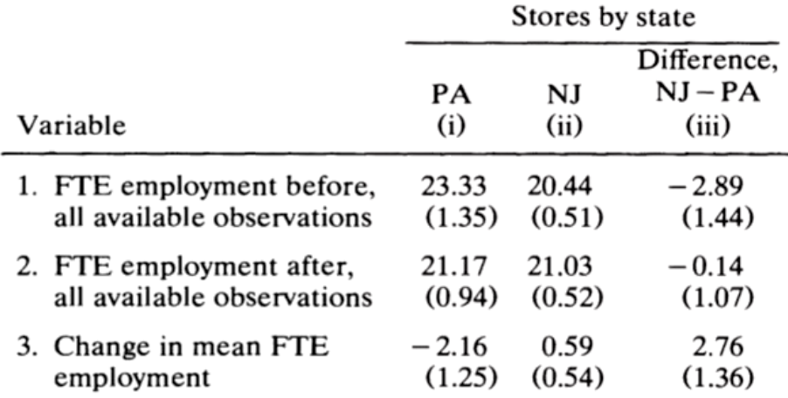

Simply comparing pre-post is naïve, because things happen in the world (such as economic downturn).

**Difference 1:** Post-minimum wage – Pre-minimum wage

**Difference 2:** NJ – PA

**Leveraging both gives us difference-in-differences.**

Before we’ve used D to introduce treatment, we’re leaving that behind.

Data structure for a 2-period diff-in-diff generally takes 2 forms:

1. Panel data
   1. A sample of units, where each unit is observed at two time points.
2. Repeated Cross Section
   1. Two random cross-sectional samples of units, collected at two time points, where each unit is observed only once.

**Notation**

|  |  |  |
| --- | --- | --- |
|  | Notation | Notes |
| Units | i |  |
| Time periods | t | 1 = post-treatment,  0 = pre-treatment, |
| Groups indicator | G-i | 1 = treatment group,  0 = control group |
| Treatment indicator | Z-it | 1 when Gi = 1 & t = 1, 0 otherwise. |
| Potential Outcome for unit *i* in period *t* when not treated | Y-it(0) |  |
| Potential Outcome for unit *i* in period *t* when treated | Y-it(1) |  |

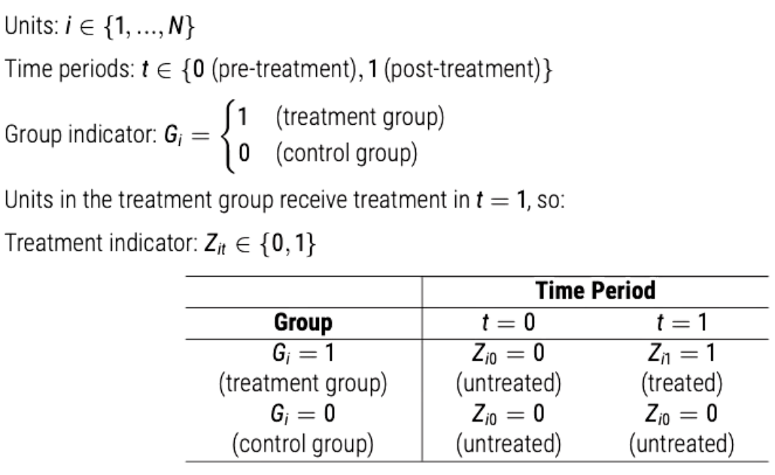

**So, if we have 100 units, measured twice, split into two groups 50/50, we will have:**

**50 units where Z-it = 1,**

**100 units where G = 1,**

**100 units where t = 1.**

Now, let’s think about potential outcomes Y-it(z) as:

Y-it(0): potential outcome for unit *i* in period *t* when not treated,

Y-it(1): potential outcome for unit *i* in period *t* when treated.

The causal effect for unit *i* at time *t* is: **Tau-it = Y-it(1) – Y-it(0)**

Observed outcomes Y-it are realised as: **Y-it = Y-it(0)*(1 – Z-it) + Y-it(1)*Z-it**

**Identification Strategies**

Estimand: ATT in the post-treatment Period

We want to focus on post-treatment because that incorporates the potential change from the intervention of study.

Tau-ATT = E[Y-i1(1) – Yi1(0) | Gi = 1]

Tau-ATT = E[Y-i1(1) | Gi = 1] - E[Y-i1(0) | Gi = 1]

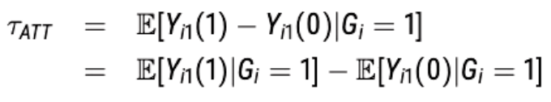

In the above, is it all observed? No! The red bit is not observed as it is the expected value of Y-I when in post-period & part of the treatment group, but Z is still equal to 0. Z will always be 1 in this case if *i*  is in post-treatment period **and** the treatment group.

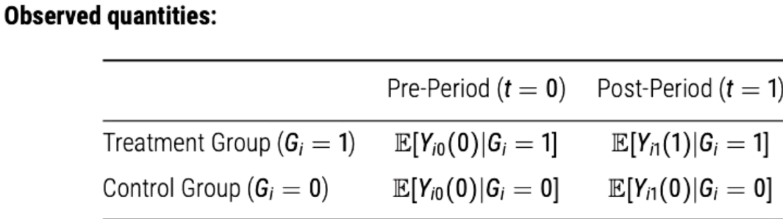

Our problem is now that we have a missing potential outcome: E[Y-i1(0) | Gi = 1], i.e., what is the average post-period outcome for the treated group in the **absence** of treatment?

**Potential Control Strategies for Identification**

1. **Before vs. After** 
   1. Use E[Y-i1 | Gi = 1] – E[Y=i0 | Gi = 1] for Tau-ATT
   2. 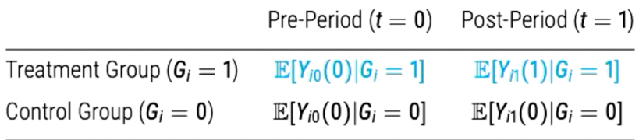
   3. Assumes:
      1. Treatment timing is independent of potential outcomes.
         1. Layman’s: there are no unobserved variables that contributed to this difference.
         2. Thus, there is no change in average potential outcome over time.
         3. There is no confounder that makes the pre-period potential outcome a poor *proxy* for the post-period potential outcome.
         4. 
         5. Very strong assumption!! Aint gonna happen!
2. **Treated vs. Control in Post-period**
   1. Use E[Y-i1 | Gi = 1] – E[Y-i1 | Gi = 0] for Tau-ATT
   2. 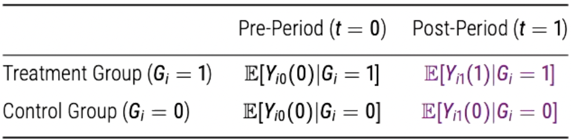
   3. Assumes:
      1. Our missing potential outcome is exactly equal to the observed potential outcome in post-period for control group.
      2. We’re back in SOO worlds, assuming ignorability.
      3. 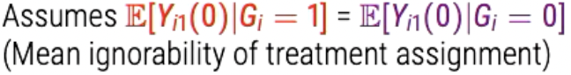
3. **Difference-in-Differences**
   1. Use (E[Y-i1 | Gi = 1] – E[Y=i1 | Gi = 0]) – (E[Y-i0 | Gi = 1] – E[Y=i0 | Gi = 0])
   2. 
   3. 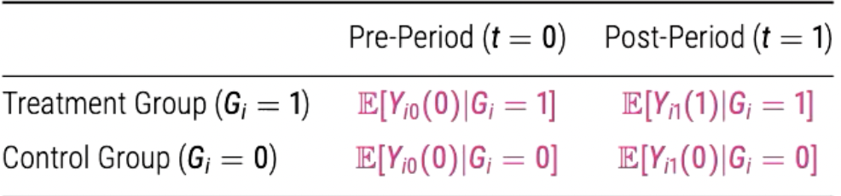
   4. In laymans: Minus the difference between treated and untreated before treatment from the difference between treated and untreated after treatment.
      1. We’re using all the data to control for the history and maturation effects that effect units over time.
   5. Assumes:
      1. **Parallel Trends Assumption**
         1. Definition: The difference between pre and post for the treated unit in terms of their control potential outcomes is equal to the difference (pre and post) in the control potential outcomes for the control unit.
         2. 
         3. The unobserved ‘missing potential outcome’ that we’re trying to estimate, then, is the control potential outcome for the treated.
         4. Parallel trends in control potential outcomes, not treated potential outcomes because the treatment intervention might interrupt this.
         5. Basically, we’re assuming that the two units would have trended the same had the treated unit not been treated.
         6. This is a gentler assumption that conditional ignorability etc.
         7. Parallel trends is an assumption about **potential outcomes, and thus we need to ‘quasi-validate’ it.**

**Parallel Trends Assumption**

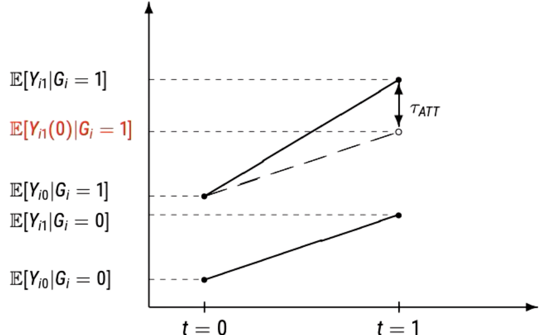

**What type of confounding does diff-in-diff make us robust to?**

1. Unobserved confounding that is time-invariant and additive.
   1. Time-invariant allows us to compare differences in ‘levels’ of Y.
   2. They correspond to some linear additive model.
2. Unobserved confounding that is time-varying.
   1. Diff-in-diff is **not** robust to time-varying covariates.
      1. For example, change in outlook on Y might change differently for a 3-year period from 15-18 compared to a 3-year period from 45-48.
      2. There’s a different ‘slope.’

**Identification with Difference-in-Differences**

Under the parallel trends assumption:



*The ATT can be nonparametrically identified as:*

Tau-ATT = (E[Y-i1 | Gi = 1] – E[Y-i1 | Gi = 0]) - ( E[Y-i0 | Gi = 1] – E[Y-i0 | Gi = 0])

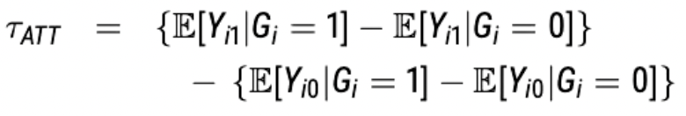

**Estimation and Inference**

*Panel Data*

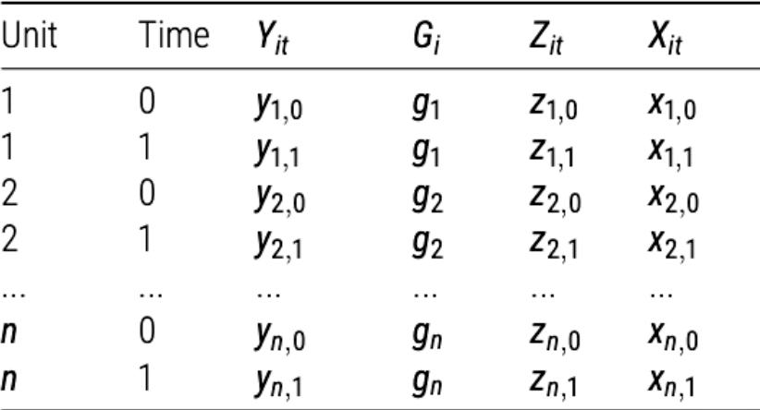

Each unit observed twice (one in time 0, one in time 1).

Time-variant = X-it, Z-it & Y-it.

Time-invariant = Gi, Unit.

Plug-in Estimation for Panel Data (difference in difference-in-means):

**ATE**

Estimand = Tau-ATT = (E[Y-i1 | Gi = 1] – E[Y-i1 | Gi = 0]) - ( E[Y-i0 | Gi = 1] – E[Y-i0 | Gi = 0]) = 

Difference in difference-in-means = 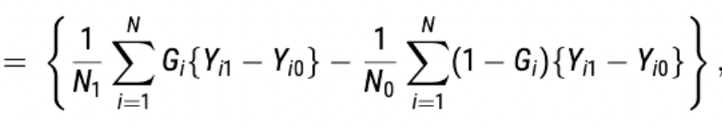

**ATT**

Estimand = Tau-ATT = E[Yi(1) – Yi(0) | Gi = 1, Ti = 1] =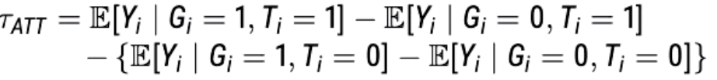

Difference in difference-in-means: 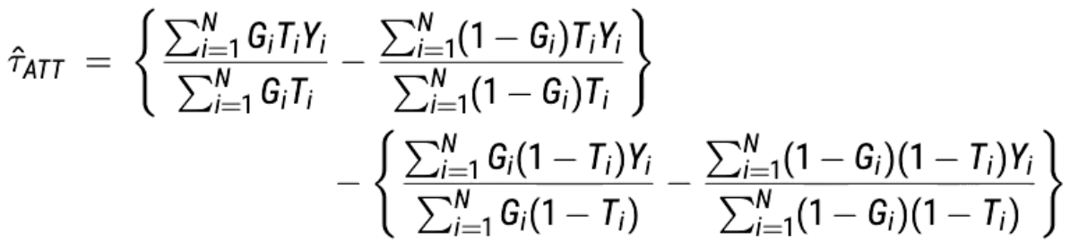

**Regression Estimator for Panel Data**

Consider: Y-it(z) = alpha-i + Beta1*t + Beta2*z + Epsilon-it

Where alpha-I is a time-invariant unobserved parameter for unit *i.* Instead of using a G indicator for treatment group, we allow each unit to have its own intercept.

Tau = Tau-ATE = Tau-ATT under parallel trends because if we can identify the treatment effect on the treated, it should be the same for everyone because Tau is constant across units. Parallel trends also implies error term is stable and so it can be controlled and accounted for. If epsilon changed over time, such as in the case of a history or maturation effect, parallel trends would not hold.

Therefore, the first-differenced regression of Y-i1 – Yi0 on Gi can unbiasedly estimate Tau-ATE = Tau-ATT.

Notice that panel data allows for unit-level unobserved confounding unlike the repeated cross-section case (group-level unobserved confounding). We can include time-varying covariates (X-it) with possible risks of post-treatment bias.

*Repeated Cross-section*

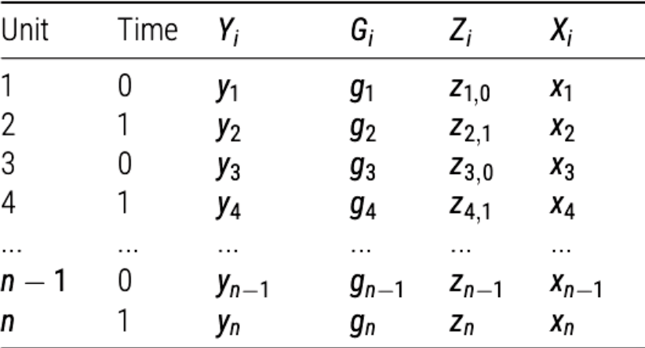

Each unit is uniquely identified by *i* as each unit is only observed one.

Plug-in Estimation for Repeated Cross Sections (difference in difference-in-means):

Estimand = Tau-ATT = E[Yi(1) – Yi(0) | Gi = 1, Ti = 1] = 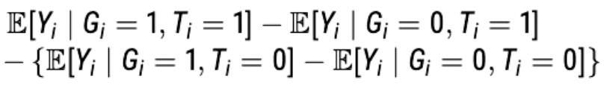

**Regression Estimator for Repeated Cross Sections**

Because Gi and Ti are both binary, the same estimator can be calculated via regression:

Y-i-hat = mu-hat + Beta1*Gi + Beta2*Ti + Tau-hat*Gi*Ti

Easy to show that Tau-hat = Tau-ATT:

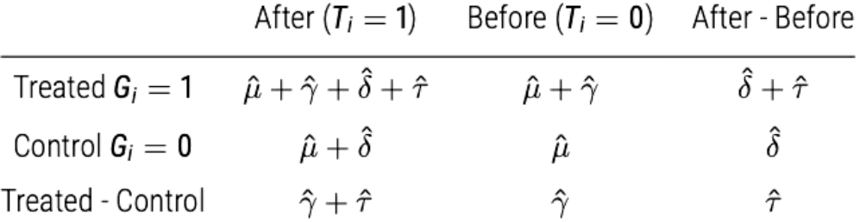

**The coefficient on the interaction is our identified causal effect.**

**REMEMBER:** Treatment assignment may or may not be assigned at the unit level. In some cases, it is assigned in a clustered fashion:

1. Geographic assignment (e.g. NJ Minimum Wage),
2. Grouped assigned (e.g. school interventions).

Standard errors should account for the level of assignment – if clustered assignment, cluster SEs (Abadie et al., 2023). If you have a small number of clusters (fewer than 30) consider a bootstrapped alternative (Cameron & Miller, 2015).

**Testing Identification Assumptions (Parallel Trends)**

WE CANNOT TEST DIRECTLY. We never observe potential outcomes.

We can, however, test for parallel pre-trends:

1. Assuming that T > 2 in the pre-period.
2. Sometimes with discrete analyses:
   1. Generate placebo treatment indicators before true treatment occurs, and test for ‘effect.’
   2. Often done through an event-study model:
      1. Fully interact treatment with time-period dummies (Freyaldenhoven et al., 2021).
      2. 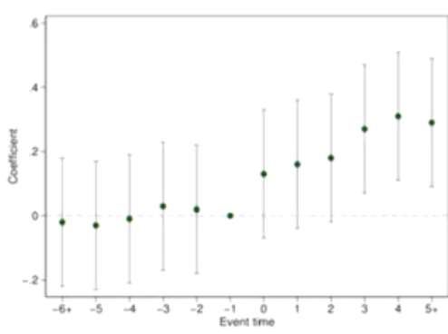
      3. Letting treatment interact with Y at every time period, ‘how much does treatment effect Y at event time T-1, T-2, T, T+1 etc.
      4. Treatment shouldn’t effect Y pre-treatment.

**Imagine if we test pre-trends and find no statistically significant difference? Is this good evidence for the parallel trends assumption?**

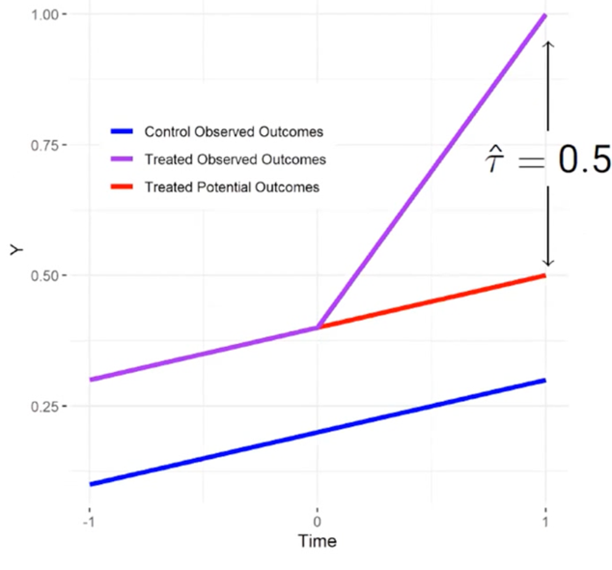

Consider a case where Tau = 0.5 and where parallel trends in potential outcomes holds, as on the left. (The left is the true Tau).

Here, we can safely use the trend in the control as a proxy for the trend in the treated.

Our diff-in-diff estimator is an unbiased estimator of Tau.

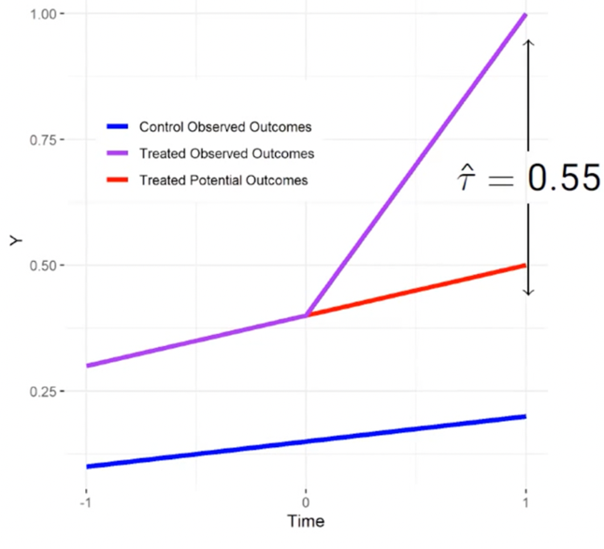

Now, consider a case where Tau = 0.5 and a non-statistically significant linear violation of parallel trends. (there are non-linear trends, but not enough to violate in SS fashion). This is something we encounter a fair bit.

Here, the trend in the controls is a less good proxy for the trend in the treated (red line, unobserved). So, our diff-in-diff estimator ends up ‘missing’ Tau (by approximate linear violation).

**Instrumental Variables**

This is a method for dealing with unobserved confounders that affect outcome and treatment assignment. We use an ‘instrument,’ which is a variable that is correlated with the treatment and is only related to the outcome via treatment.

Often, we cannot ensure compliance with treatment (whether you did what you were assigned [treatment vs. control]). Units choosing to comply/not comply may differ in unobserved characteristics from units that do the opposite.

For example, if we offer a pill and a placebo in an RCT, those who are more trusting in treatment (pill) might take it, whereas those who are much less trusting of authority figures might be allocated to treatment, but don’t take the pill. This covariate, trusting vs. non-trusting, may confound and affect the outcomes we’re trying to study.

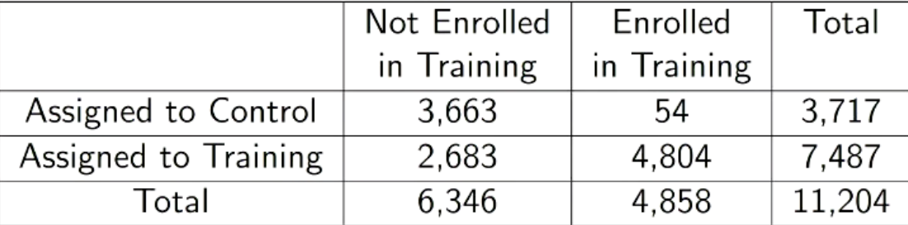

In above, 54 assigned to control actually took the training, and 2,683 assigned to training didn’t actually do it. Can we still learning anything in such a setting?

**Setup**

1. Randomised encouragement: Zi (0 or 1).
2. Treatment as potential outcomes under Z: D-1i, D-0i (treatment-level potential outcomes).
   1. For individual i, what would their treatment status be under encouragement?
   2. For individual i, what would their treatment status be under non-encouragement?
      1. In case of perfect compliance, Zi = Di
      2. D-zi = 1: would receive the treatment if Zi = z,
      3. D-zi = 0: would not receive treatment if Zi = z.
      4. D-1i = 1 when encouraged to take treatment and takes treatment.
      5. Note: encouragement does not equal treatment.
      6. Instead: **treatment is a *function* of encouragement.**
3. Observed Treatment Indicator: Di = D-zi,i for Zi = z.
4. Potential outcomes of Yi under Di and Zi: Y(zi, D-zi,i)i
5. Observed outcome of Yi: Yi = Y(Zi, Dzi,i) for Zi = z,
   1. Thus, observed outcome of Yi can be written as Yi = Y-Zi,i

|  |  |  |  |
| --- | --- | --- | --- |
|  | Notation | Notes | Example |
| Units | i |  |  |
| Encouragement | Zi | 1 = encouraged,  0 = not encoruaged | Encouragement to take the pill |
| Treatment | Di | 1 = treatment group,  0 = control group | Did you take the pill? |
| Treatment Potential Outcomes | Z-it | D-zi = 1 if would receive the treatment if Zi = z, D-zi = 0: would not receive treatment if Zi = z | D-1i = 1 when encouraged to take treatment and takes treatment |
| Potential Outcomes of Outcome | Y(Zi, D-Zi, i) |  |  |
| Observed outcome | Yi = Y-Zi,i |  | Y is a function of Z, through D. |

**Compliance Types & Principal Strata**

Given our setup, we can define four compliance types:

1. Unit i is a complier if: d-1i = 1 and D0i = 0
2. Unit i is an always-taker if D-1i = D0i = 1,
3. Unit i is a never-taker if D-1i = D0i = 0,
4. Unit i is a defier if D-1i = 0 and D-0i = 1

These compliance types are across both encouragement and non-encouragement.

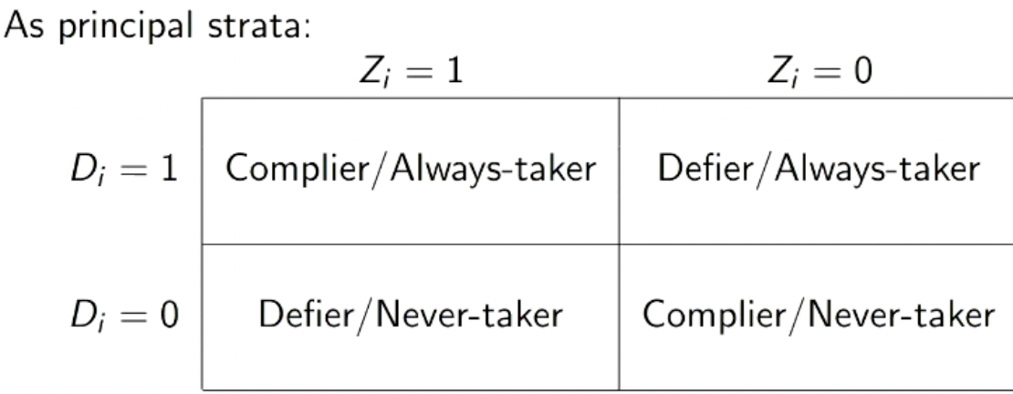

**Experimental Setting (Encouragement Design)**

If we randomize Z, then:

Tau-ITT = E[Yi | Zi = 1] – E[Yi | Zi = 0]

**Observational Setting (Instrumental Variables Design)**

Instrumental Variables is the observational analogue for Encouragement Design.

**Assumptions**

The ITT only allows us to say something about the effect of Z on Y. What about the effect of D (which is what we’re after)? This is where the assumptions around Instrumental Variable design can help.

Five key assumptions underpin IV:

1. **SUTVA**
2. **Exogeneity (ignorability of the instrument)**
   1. Potential outcomes *and* potential treatment status are independent of the instrument.
   2. 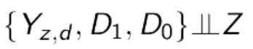
      1. Potential outcomes are independent of instrument (sufficient for ITT),
      2. Potential outcomes of Treatment are independent of instrument.
         1. All of our compliance types are, in expectation, balanced across levels of Z.
   3. Plausible when we randomize Z.
3. **Monotonicity:**
   1. There are no defiers.
   2. D1 >= D0.
4. **Exclusion Restriction:**
   1. Z only affects outcome through treatment.
      1. Achieved through ‘as-if’ randomization of Z, which de-correlates Z and confounders.
      2. So, treatment is the actual thing that affects potential outcomes – not Z.
      3. Big problem! If Z isn’t randomized, it might be confounded with observed covariates.
5. **Relevance** of the instrument:
   1. The probability of treatment under Z = 1 is not equal to probability of treatment under Z = 0.
   2. In other words, Z has to affect D. Instrument needs to affect treatment.

**Graphical Representation of Assumptions**

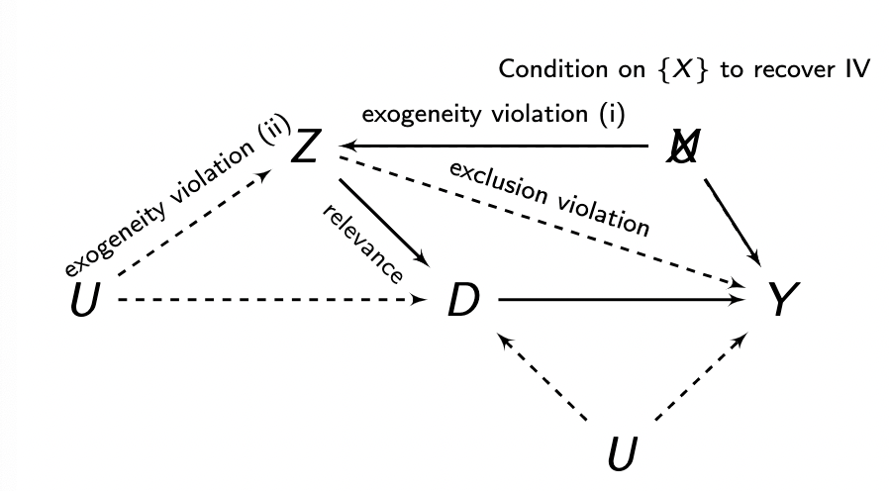

**Decomposing Tau-ITT**

The ITT, whilst interesting, is not the most scientifically interested estimand. We want to understand the impact of *treatment*, not *encouragement*.

Tau-ITT can be decomposed into a combination of subgroup ITTs:

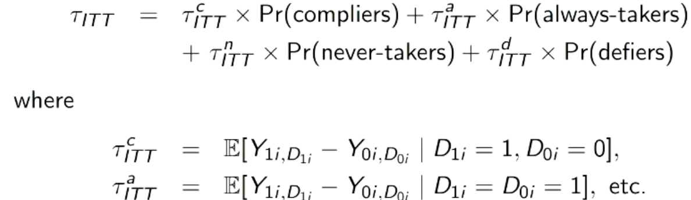

The ITT is thus made up of the weighted average of ITT for compliers, always-takers, never-takers and defiers.

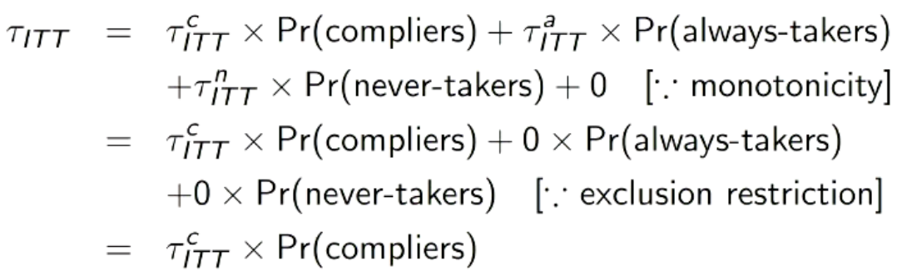

Under monotonicity and exclusion restriction, this simplifies as:

* + - Always-takers & never-takers reduced to 0 by exclusion restriction. If D is constant, then Y1 and Y0 are equal because encouragement cant affect outcome other than through level of D. Given that it cant affect outcome other than through D, then encouragement effect must be 0.
      1. Y1,1 – Y0,1 = 0
    - Defiers reduced to 0 by monotonicity as we assume these away.

Therefore, we can identify Tau-ITT for compliers nonparametrically, using:

**Tau-ITT-compliers = Tau-ITT/Pr(compliers)** 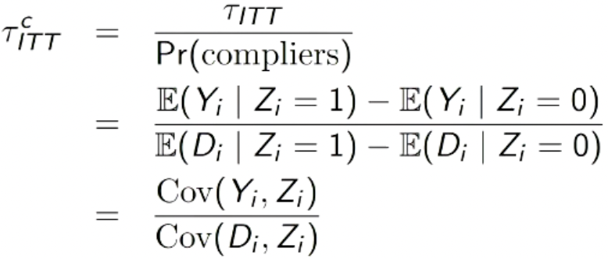

**Difference in means between encouraged group and non-encourage group**

**Tau-ITT-Compliers** can be interpreted as a Local Average Treatment Effect (LATE) for compliers (local as it only applies to specific sub-population of sample):



The problem is that we will never reaaally be able to identify who the compliers are. Different encouragements (instruments) could also have different complier groups – if you design an encouragement, it might be rubbish at encouraging 1 group and very good at encouraging another (see race, gender).

**IV: Plug-in Estimator**

A plug-in estimator called the Wald Estimator:

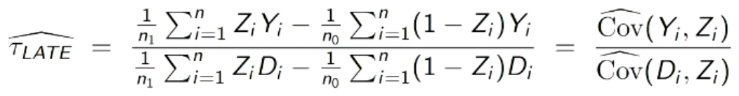

Is consistent but not unbiased for finite samples. Small sample bias may be considerable when the instrument is weak (when Cov(Di, Zi) is approx. 0). An active area of debate – Stock & Yogo (2005), Lee et al., (2022), Angrist & Kolesár (2023).

**IV: Two-Stage Least Squares Estimator (2SLS)**

Consider two equations:

1. **D = tau + beta*Z + epsilon (first stage)**
   1. Regress D on Z and obtain fitted values (D-hat’s)
2. **Y = alpha + beta*D + epsilon (second stage)**
   1. Regress Y on D-hat
   2. Why fitted values? We’re asking, ‘what is the *residual variation* after we model Y on Z?’
3. Get coefficient on fitted values of D and that would be our IV estimate of interest.

**Summarised Logic**

1. We observe a variable, called the instrument, that **is correlated** with the outcome.
2. We assume the instrument **does** **not have a causal effect** on the outcome.
3. We assume the instrument **does have a causal effect** on the treatment.
4. We assume the instrument is **randomly assigne**d (or ‘as if’).
5. From step 4, the causal effect of the instrument on the treatment is their **correlation** in the data.
6. Since the instrument is **randomly assigned,** it is **not correlated** with any other possible confounder except the treatment.

*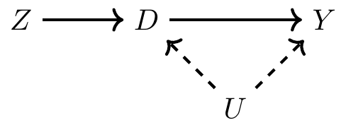Problem is the unobserved confounder above that is affecting both D and Y!*

* Even though Z (instrument) is correlated with outcome (Y), we assume it is **non-causal,** so can remove line from Z to Y (STEP 2).
  + **https://www.youtube.com/watch?v=nsr9eh-qVPg**
* Even though Z (instrument) could be correlated with pre-treatment variables (confounders), because Z is randomly assigned, it can’t be causing pre-treatment variable changes (STEP 4). So, we can remove the line between Z and U.
* Leaves us with one possibility – that the instrument has an effect on outcome **through** the treatment variable. Any correlation we see between instrument and outcomemust be picking up on the **combined effect** of instrument on treatment and treatment on outcome.
* We need to now remove the effect of instrument on treatment. We do so, due to (STEP 5), by removing the correlation between the instrument and treatment, thus isolating the effect of treatment on outcome.

**Regression Discontinuity Design**

Designs in which participants are assigned to the intervention and the control conditions based on a cut-off score on a pre-intervention measure that typically assesses need or merit.

**Sharp Regression Discontinuity Design**

Simply adjusting for Xi does not work because of lack of common support. All treated have values greater than c, all control have values less than c.

Intuition: Right at the cutpoint Xi = c, assignment to Di may be considered as-if random.

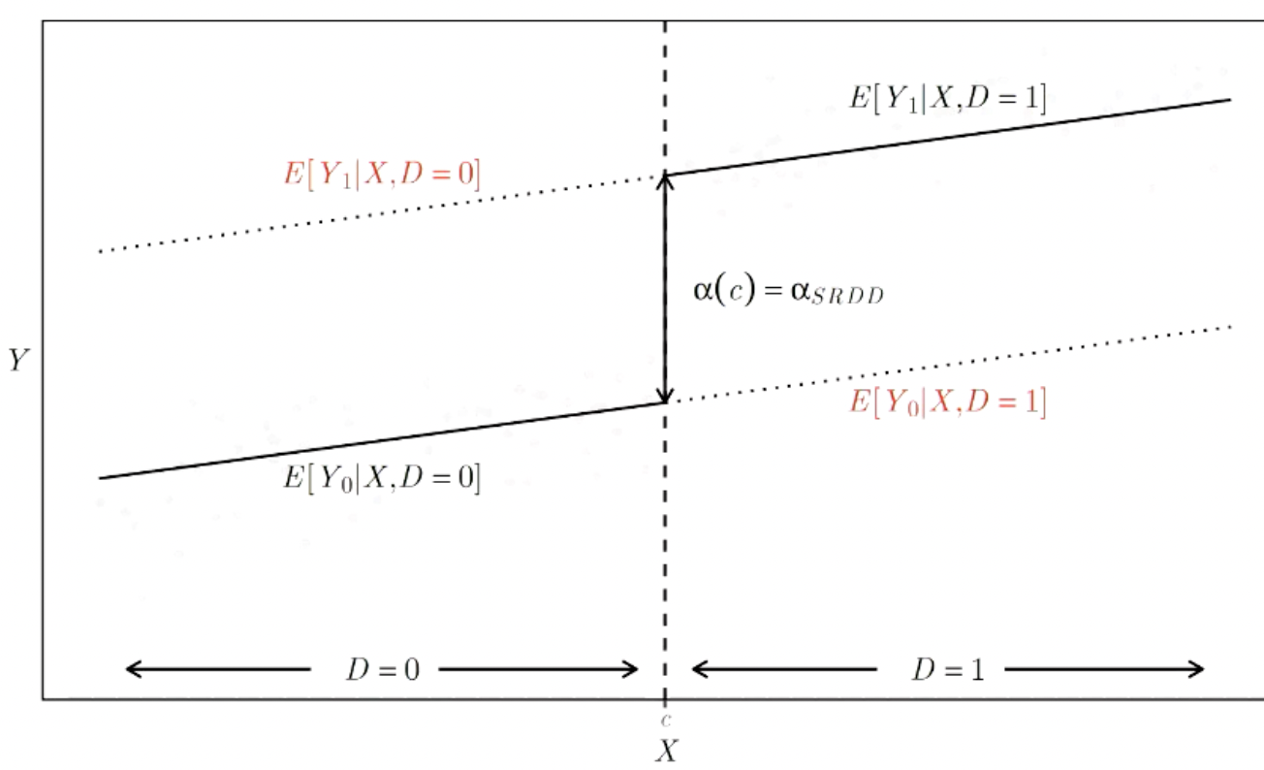

We’re assuming that if we were to extend these lines further, they would continue on – these are the missing potential outcomes.

**Identification Assumptions**

1. **SUTVA**
2. **Conditional Independence** 
   1. Once you condition on X, you have independence between treatment and potential outcomes.
   2. 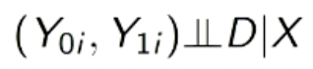
   3. Trivially satisfied because D is determined by X and thus is *always* conditioned on X.
   4. Once you know X, you know everything about D also – there cannot be any surplus variation that isn’t accounted for by knowing X.
3. **Continuity** 
   1. The expected value of Y-1i and Y-0i given X are continuous in X around the threshold X = c.
   2. The regression line would have continued smoothly across the threshold.
   3. In other words, there is *no discontinuity in potential outcomes.*

With the two above assumptions, we can identify the average treatment effect for those at the threshold:

Alpha-SRDD (not sure why it’s alpha now) = E[Y-1i | X = c] – E[Y-0i | X = c]



Which we identify for those arbitrarily close to threshold as:

Alpha-SRDD = limE[Y-1i | X = c] – limE[Y-0i | X = c]



Where lim is basically just the distance from cutofF

**Estimation**

1. **Trim the sample to a reasonable window around the threshold c.**
   1. The ‘discontinuity sample.’
   2. c – h <= Xi <= c + h
      1. Where h is some positive value that determines the size of the window.
   3. How do we choose h in a principled way?
      1. Frame estimation in RDD as a prediction problem: we want to predict the unobserved value of Y when X = c.
      2. h may be determined by a cross-validation approach.
         1. The bandwidth can be treated as a ‘tuning parameter.’
         2. But, this implies a classical bias-variance trade-off.
         3. Need to correct for that bias: see Calonico, Cattaneo & Titiunik 2014.
2. Center the forcing variable, as deviation from the threshld:
   1. X-approx = X – c
   2. X-approx > 0 if X > c and D = 1
   3. X-approx < 0 if X < c and D = 0
   4. X-approx = 0 if X = c and D = 0
3. Decide on a model for E[Y | X]
   1. Linear with same slope for E[Y-0i | Xi] and E[Y-1i | Xi],
   2. Linear, different slopes for E[Y-0i | Xi] and E[Y-1i | Xi],
   3. Non-linear,
   4. Always begin with visual inspection through scatters, kernel densities, LOESS, piecewise linear fits.

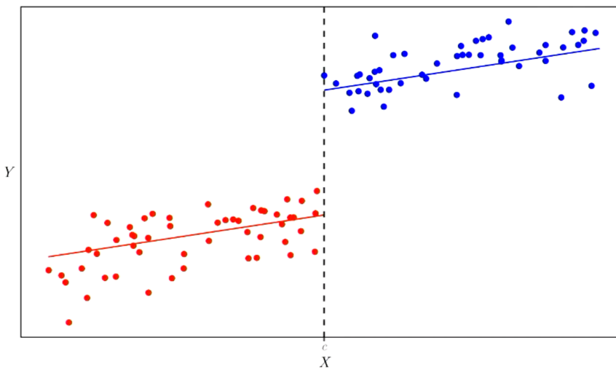

*1: Common Slopes Model!*

**Common Slopes:**

1. E[Y-0i | X] = mu + Beta*X
2. E[Y-1i – Y-0i | X] = alpha
3. Therefore E[Y-1i | X] = alpha + E[Y-0i | X] = alpha + mu + Beta*X
4. Since D is completely determined by X, we have:
   1. 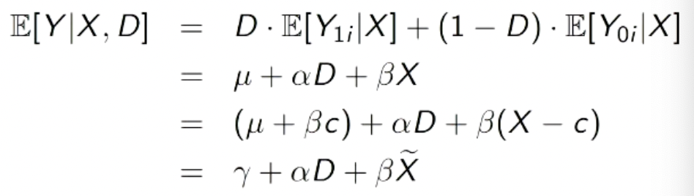
5. So, in summary, we just run a regression of Y on D and X-approx = X – c

**Different Slopes:**

1. E[Y-0i | X] & E[Y-1i | X] are distinct linear functions of X, so the average effect of the treatment, E[Y-1i – Y-0i | X] varies with X:
   1. E[Y-0i | X] = Mu-0 + Beta-0*X
   2. E[Y-1i | X] = Mu-1 + Beta-1*X
2. So, alpha(X) = E[Y-1i – Y-0i | X] = (mu1 – mu0) + (Beta1 – Beta0)*X
3. Since D is completely determined by X, we have:
   1. 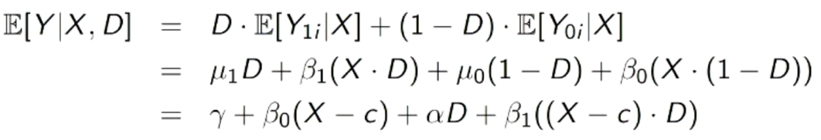
4. In summary, we regress Y on X-tilde, D, and the interaction of X-tilde and D
   1. Estimate of the coefficient alpha of D estiamtes the average treatment effect at X = c.

**Robustness/Falsification Checks**

Sensitivity: Are results sensitive to alternative specifications or choices of h?

* Need to demonstrate a plot for every value of h.
  + *Across all different choices of h, this is what the point estimate looks like.*
* Balance checks
  + *Do covariates or pre-treatment values of Y jump at the threshold?*
* Placebo thresholds
  + *Do jumps occur at placebo thresholds at different values of c?*
* Sorting: Do units sort around the threshold?
  + Can people self-select into either side of the threshold? If so, this is a big problem.
  + McRary 2008 checks for discontinuity in density at the threshold.
* All of this is rdrobust in R!

Here, we are calculating the **LATE for the threshold.**

**Fuzzy Regression Discontinuity Design**

**Setup:**

|  |  |  |  |
| --- | --- | --- | --- |
|  | Notation | Notes | Example |
| Units | i |  |  |
| Encouragement | Zi | 1 if encouraged, 0 if not. |  |
| Treatment | Di | 1 = treatment group,  0 = control group | Di is not a function of Zi! Treatment as a function of the instrument. |
| Forcing Variable | Xi | Perfectly determines the value of Zi, not Di, with cutpoint c. May be correlated with Y0i and Y1i. | Zi = 1 where Xi > c.  Something is pushing you intro treatment or control based on a threshold. |

Forcing variable assigns Z, not D! Encouragement, not treatment!

The Causal Estimand for the fuzzy RDD is the **LATE for compliers at the threshold.** This combines the language of RDD (LATE at the threshold) with IV (LATE for compliers).



**Assumptions:**

1. Continuity (from RDD)
2. Monotonicity (from IV)
3. Exclusion Restriction (from IV)
4. Relevance of instrument (from IV)

The identification result, under the above assumptions, is defined as:

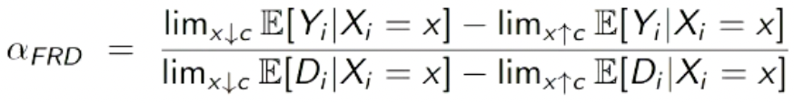

Basically, it is the RDD estimate for potential outcomes divided by the proportion of compliers.

Estimation Steps:

1. Isolate discontinuity sample,
2. Code the instrument: Z = 1{X > c}
3. Fit two-stage-least-squares
   1. First stage: Di = f(Xi) + Beta*Zi + Epsilon-i
   2. Second stage: Yi = f(Xi) + alpha*D-hat-I + epsilon-i
      1. Note: the specification of f is flexible but must be the same at both stages.
4. *Plot and estimate the outcome discontinuity and treatment discontinuity separately.*

**Internal and External Validity**

Both IV & RDD work with subpopulations. For IV, we focus on **compliers**. For RDD, we focus on the **threshold**. For fuzzy RDD, we do both – **compliers with Xi close to c** (an even smaller sample). This has implications for external validity! Only with **very strong assumptions** can we move from the **LATE to a more general estimand**

|  |  |  |  |  |  |
| --- | --- | --- | --- | --- | --- |
| **ASSUMPTIONS** | | | | | |
| **Method** | **Assumption 1** | **Assumption 2** | **Assumption 3** | **Assumption 4** | **Assumption 5** |
| **RCT** | SUTVA:  No interference between units &  Only one version of treatment. |  |  |  |  |
| **Subclassification** | SUTVA:  No interference between units &  Only one version of treatment. | Conditional ignorability/independence:  Once we condition on x, we get conditional independence between potential outcomes and treatment. | Common Support:  The probability of receiving treatment for any given level of X is never 0 and never 1. |  |  |
| **Matching** | SUTVA:  No interference between units &  Only one version of treatment. | Conditional ignorability/independence:  Once we condition on x, we get conditional independence between potential outcomes and treatment. | Common Support:  The probability of receiving treatment for any given level of X is never 0 and never 1. |  |  |
| **Weighting** | SUTVA:  No interference between units &  Only one version of treatment. | Conditional ignorability/independence:  Once we condition on x, we get conditional independence between potential outcomes and treatment. | Common Support:  The probability of receiving treatment for any given level of X is never 0 and never 1. |  |  |
| **Regression** | SUTVA:  No interference between units &  Only one version of treatment. | Conditional ignorability/independence:  Once we condition on x, we get conditional independence between potential outcomes and treatment. | Functional Form (Linearity):  Implies constant treatment effect. Assumptions around functional form. | Constant Treatment Effect:  Tau for any individual is equal to Tau for all other individuals. |  |
| **Diff-in-Diff** | SUTVA:  No interference between units &  Only one version of treatment. | Parallel Trends: Parallel trends in control potential outcomes, not treated potential outcomes. |  |  |  |
| **IV** | SUTVA:  No interference between units &  Only one version of treatment. | Exogeneity:  Potential outcomes *and* potential treatment status are independent of the instrument. | Monotonicity:  There are no defiers. | Exclusion Restriction:  Instrument (Z) only affects outcome (Y) through treatment (D). | Relevance of Instrument:  Z has to affect D. Instrument needs to affect treatment. |
| **Sharp RDD** | SUTVA:  SUTVA:  No interference between units &  Only one version of treatment. | Conditional ignorability/independence:  Once we condition on x, we get conditional independence between potential outcomes and treatment. This is trivially satisfied because D is determined by X and thus is *always* conditioned on X. | Continuity:  The expected value of Y-1i and Y-0i given X are continuous in X around the threshold X = c. In other words, there is *no discontinuity in potential outcomes.* |  |  |
| **Fuzzy RDD** | SUTVA:  No interference between units &  Only one version of treatment. | Continuity:  The expected value of Y-1i and Y-0i given X are continuous in X around the threshold X = c. In other words, there is *no discontinuity in potential outcomes.* | Monotonicity:  There are no defiers. | Exclusion Restriction:  Instrument (Z) only affects outcome (Y) through treatment (D). | Relevance of Instrument:  Z has to affect D. Instrument needs to affect treatment. |

|  |  |  |  |  |  |  |  |
| --- | --- | --- | --- | --- | --- | --- | --- |
| **NOTATION** | | | | | | | |
| **Method** | **Treatment Effect** | **Treatment** | **Observed Outcome** | **Potential Outcomes** | **Covariates** | **Instrument** | **Unique** |
| **RCT** | Tau | Di | Yi | Y-1i & Y-0i |  |  |  |
| **Subclassification** | Tau | Di | Yi | Y-1i & Y-0i | Xi,  Xj for strata group |  |  |
| **Matching** | Tau | Di | Yi | Y-1i & Y-0i | Xi |  | Propensity score = *Pi(Xi) = Pr(Di = 1 | Xi)* |
| **Weighting** | Tau | Di | Yi | Y-1i & Y-0i | Xi |  | IPW:  For treated: Y * 1/Pi(Xi)  For control:  Y * -1/(1-Pi(Xi) |
| **Regression** | Tau, Beta1 | Di | Yi | Y-1i & Y-0i | Xi |  | Yi(d) = Alpha + Beta1*d + Beta2*Xi + Epsilon-i (for d = 0,1) |
| **Diff-in-Diff** | Tau | Z-it  (1 when Gi = 1 and t = 1, 0 otherwise( | Yi | Y-it(z) where z is either in treated or control | Xi |  | Time periods = t,  Group indicator = Gi |
| **IV** | Tau | Di | Yi = Y-Zi,i  (Y is a function of Z, through D) | Y(Zi, D-Zi, i) | Xi | Z | Treatment potential outcomes = Z-it |
| **Sharp RDD** | Tau | Di | Yi | Y-1i & Y-0i |  |  | Xi = forcing variable,  C = cutoff,  h = window size |
| **Fuzzy RDD** | Tau | Di | Yi | Y-1i & Y-0i |  | Z | Xi = forcing variable,  C = cutoff,  h = window size |

|  |  |  |  |  |
| --- | --- | --- | --- | --- |
| **Estimands** | | | | |
| Method | Primary | Secondary | Tertiary | Notes |
| **RCT** | ATE | ATT | CATE |  |
| **Subclassification** | ATE | ATT |  |  |
| **Matching** | ATT |  |  |  |
| **Weighting** | ATE | ATT |  |  |
| **Regression** | ATE | ATT | Conditional-Variance-Weighted ATE |  |
| **Diff-in-Diff** | ATT |  |  |  |
| **IV** | ITT for Compliers, also known as LATE for compliers |  |  |  |
| **Sharp RDD** | LATE for the threshold |  |  |  |
| **Fuzzy RDD** | LATE for compliers at the threshold |  |  |  |

|  |  |  |  |
| --- | --- | --- | --- |
| **Method** | **Primary** | **Secondary** | **Tertiary** |
| **RCT** |  |  |  |
| **Subclassification** |  |  |  |
| **Matching** |  |  |  |
| **Weighting** | **For treatment, we multiply the Y value of the observed treatment units by 1/propensity_score.**  **For control units, we multiply the Y value of the observed control units by -1/(1-propensity_score)**  A picture containing text, font, line, number  Description automatically generated |  |  |
| **Regression** |  | Same as ATE but for subgroup where D = 1 |  |
| **Diff-in-Diff** | A picture containing text, font, white, typography  Description automatically generated  Post – pre,  Treated unit – control unit | In Pennsylvania, FTEs dropped from 23.33 to 21.17 (-2.16). If there was no causal effect, we would expect NJ to follow a similar pattern. However, NJ rose from 20.44 to 21.03 (+0.59). Thus, the causal effect of min wage increases is 0.59 - -2.16 = 2.76. We can also determine whether this is statistically significant. |  |
| **IV** |  |  |  |
| **Sharp RDD** |  |  |  |
| **Fuzzy RDD** |  |  |  |